Bank CRM Analysis
(Objective Questions)
Q1. What is the distribution of account balances across different regions?
After done modeling we use new measure to calculate total account balance using. DAX Query (Total Account Balance = SUM(Bank_Churn[Balance]))
Visualization:
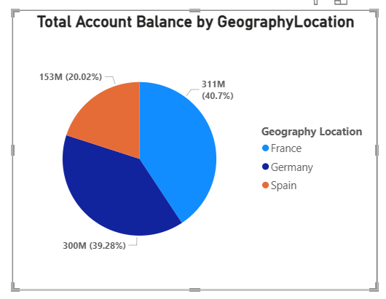

Approach:
- Objective: How are account balances spread across different regions?
Which region has the highest total account balance?
Which region has the lowest total account balance?

- Method: To solve this question, we applied a DAX calculation on the Balance column in the Bank_Churn table to compute the total balance.
Next, we used the Geographical Location category from the geographicalLocation table to group the data region-wise. This allowed us to calculate the total account balance for each geographical region.
Finally, we represented the results using a pie chart to clearly visualize which region has the highest and lowest total balance.
- Insights: France holds the highest total account balance at 311M (40.7%), contributing the largest share overall.
Germany is very close behind with 300M (39.28%), showing a nearly equal contribution.
Spain has the lowest total balance at 153M (20.02%), contributing roughly half of France’s total balance.
- Recommendation: The bank should focus on retaining and upselling customers in France and Germany, as they contribute the majority of total balances.

Q2. Identify the top 5 customers with the highest Estimated Salary in the last quarter of the year. (SQL)
Here we first import dataset in SQL after convert csv files then rename Bank DOJ to Bank_DOJ and change datatype text to date.
SQL Code:
with TotalSalaryQ4 as (select customerID,
Surname as LastName,
sum(estimatedSalary) as Total_salary
from customerinfo
where bank_doj between "2019-10-01" and "2019-12-31"
group by customerID)
select CustomerID, LastName, Total_salary as HighestSalary,
rank () over (order by total_salary desc) as "Rank"
from TotalSalaryQ4
limit 5

- Output: A single table showing
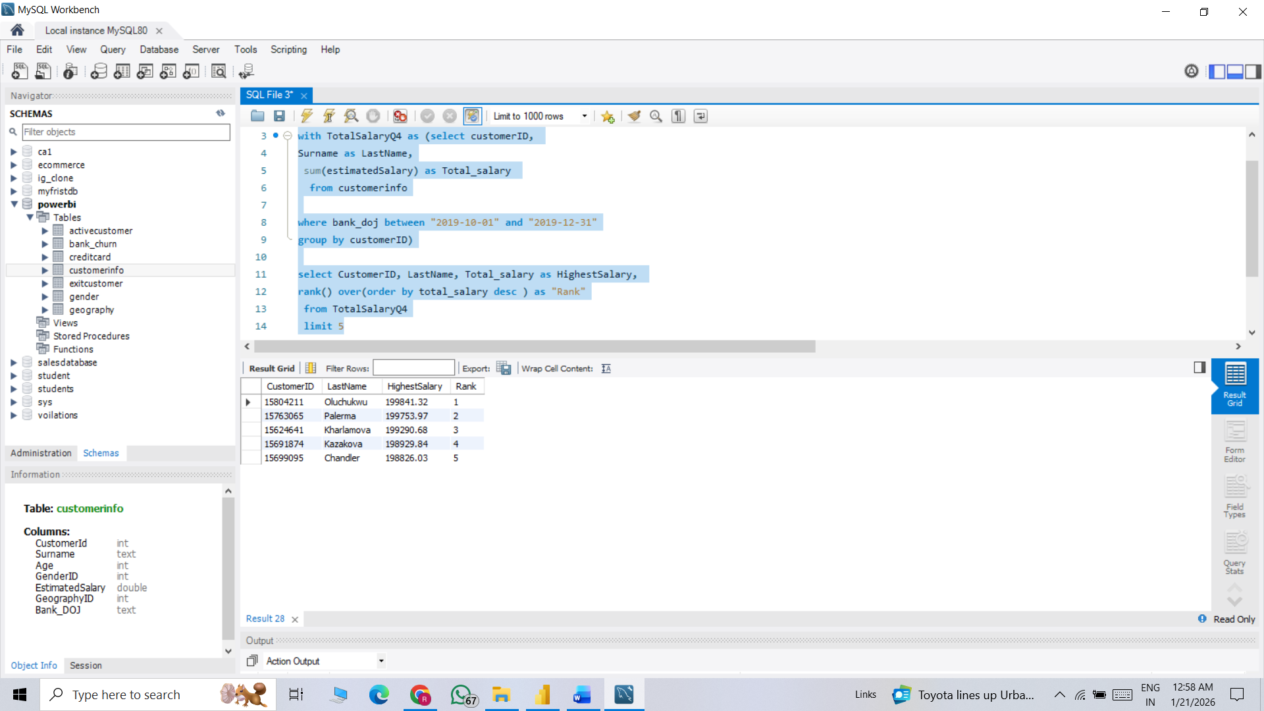
Visualization:

Approach:
- Objective:
Identify the top 5 customers with the highest Estimated Salary in the last quarter of the year. (SQL)
Identify most valuable customers in the bank?
- Method: First, we used the Customer_Info table and applied the RANK () function to rank customers based on their highest Estimated_Salary, using a CTE (Common Table Expression).
Then, with the help of the LIMIT clause, we extracted the top 5 customers who have the highest salaries among all customers.

- Insights: Customer ID 15804211 has the highest estimated salary (≈199,841), followed very closely by 15763065.
The salary difference among the top 5 customers is very small, indicating a highly competitive high-income segment.
All top 5 customers have estimated salaries close to 200K, suggesting they belong to a premium income category.

- Recommendation: The bank should target these high-salary customers with premium banking services, wealth management, and exclusive investment products to maximize revenue.

Q3. Calculate the average number of products used by customers who have a credit card. (SQL)
SQL Code:
select round(avg(numofproducts),2) as avg_Product
from bank_churn
where hascrcard = 1
- Output: A single table showing
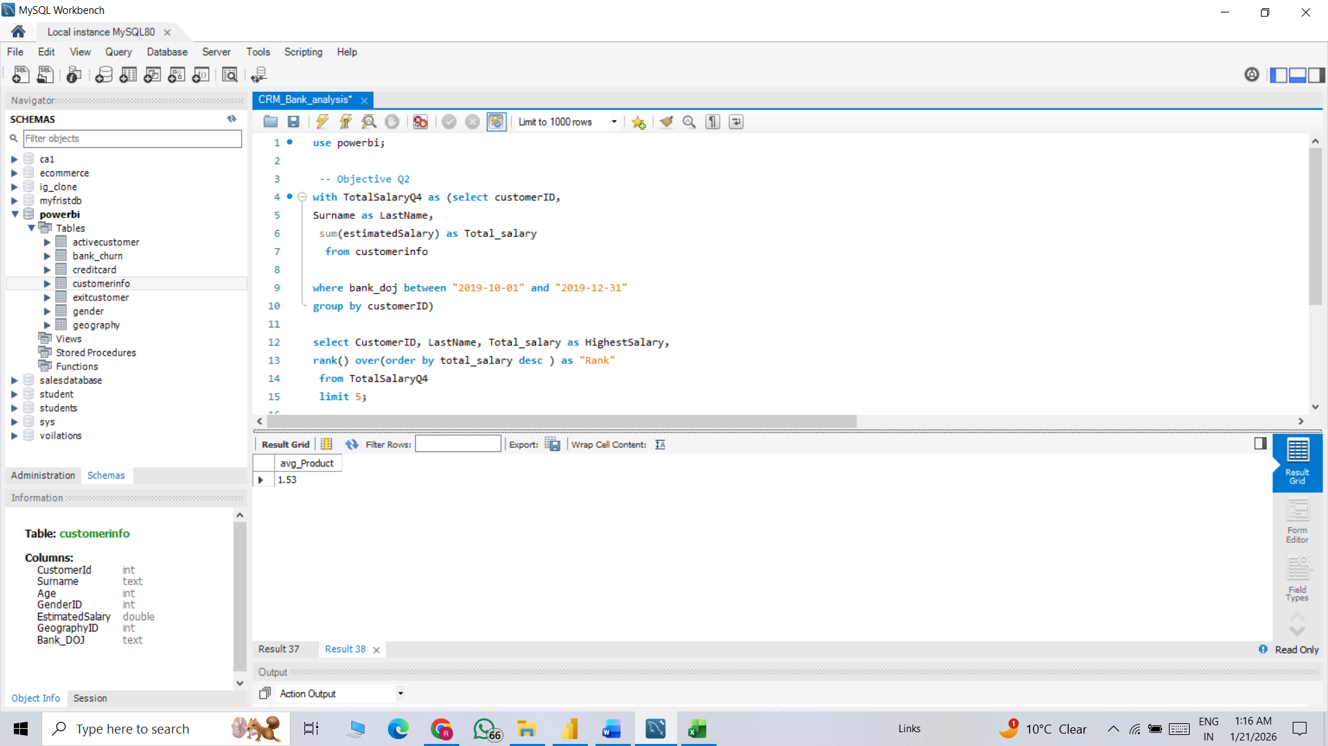

Approach:
- Objective: Calculate the average number of products used by customers who have a credit card. (SQL)
- Method: To solve this Question, we use bank_churn table after that we apply condition only customers have credit card then apply some sort of aggregation to calculate average number of products
- Insights: After applying all the necessary calculations and conditions, we found that the average number of products used per customer is 1.53 in the bank.
- Recommendation: Since the average product usage is only 1.53 per customer, the bank should implement cross-selling strategies to encourage customers to use more products

Q4. Determine the churn rate by gender for the most recent year in the dataset.
First, we calculate total number of churn customer then filter by gender category additionally apply year filter to obtain recent year churn rate
Output:
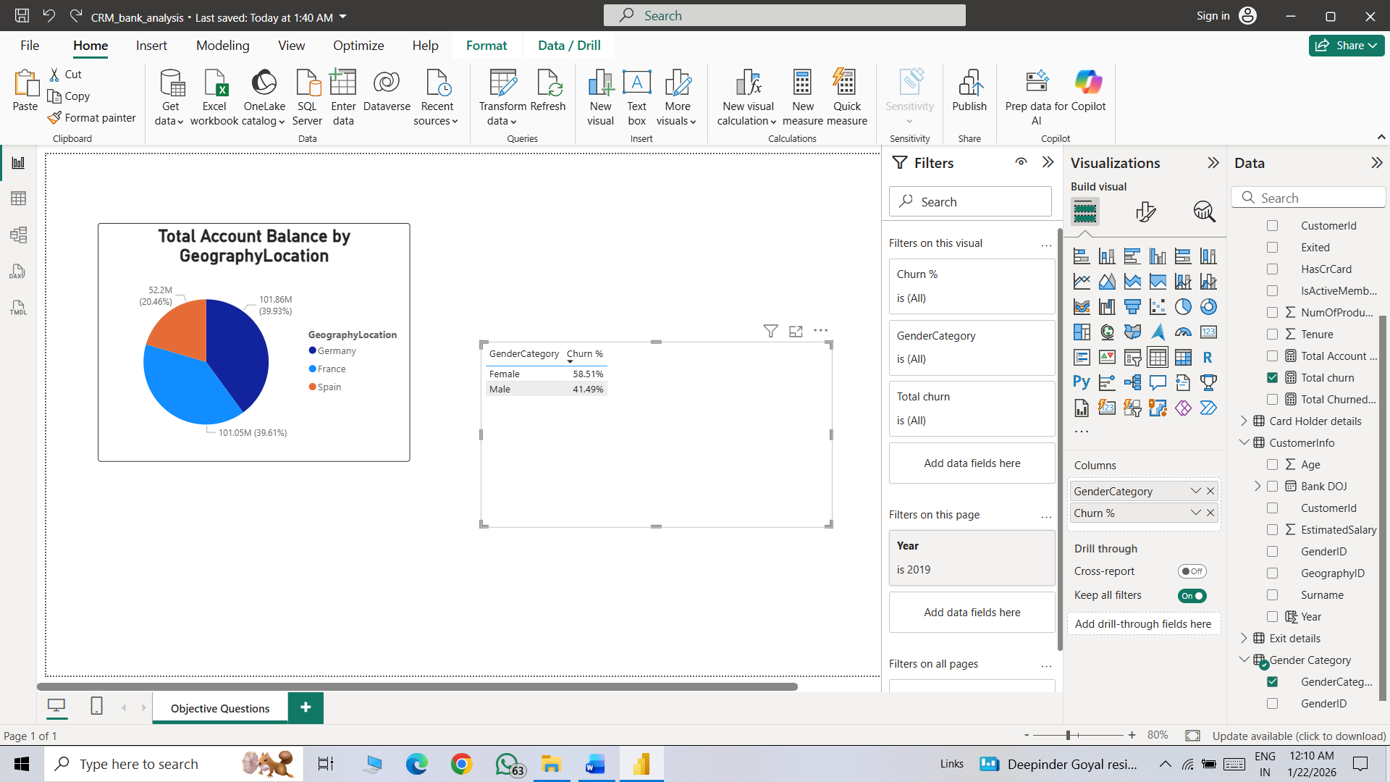
Visualization:
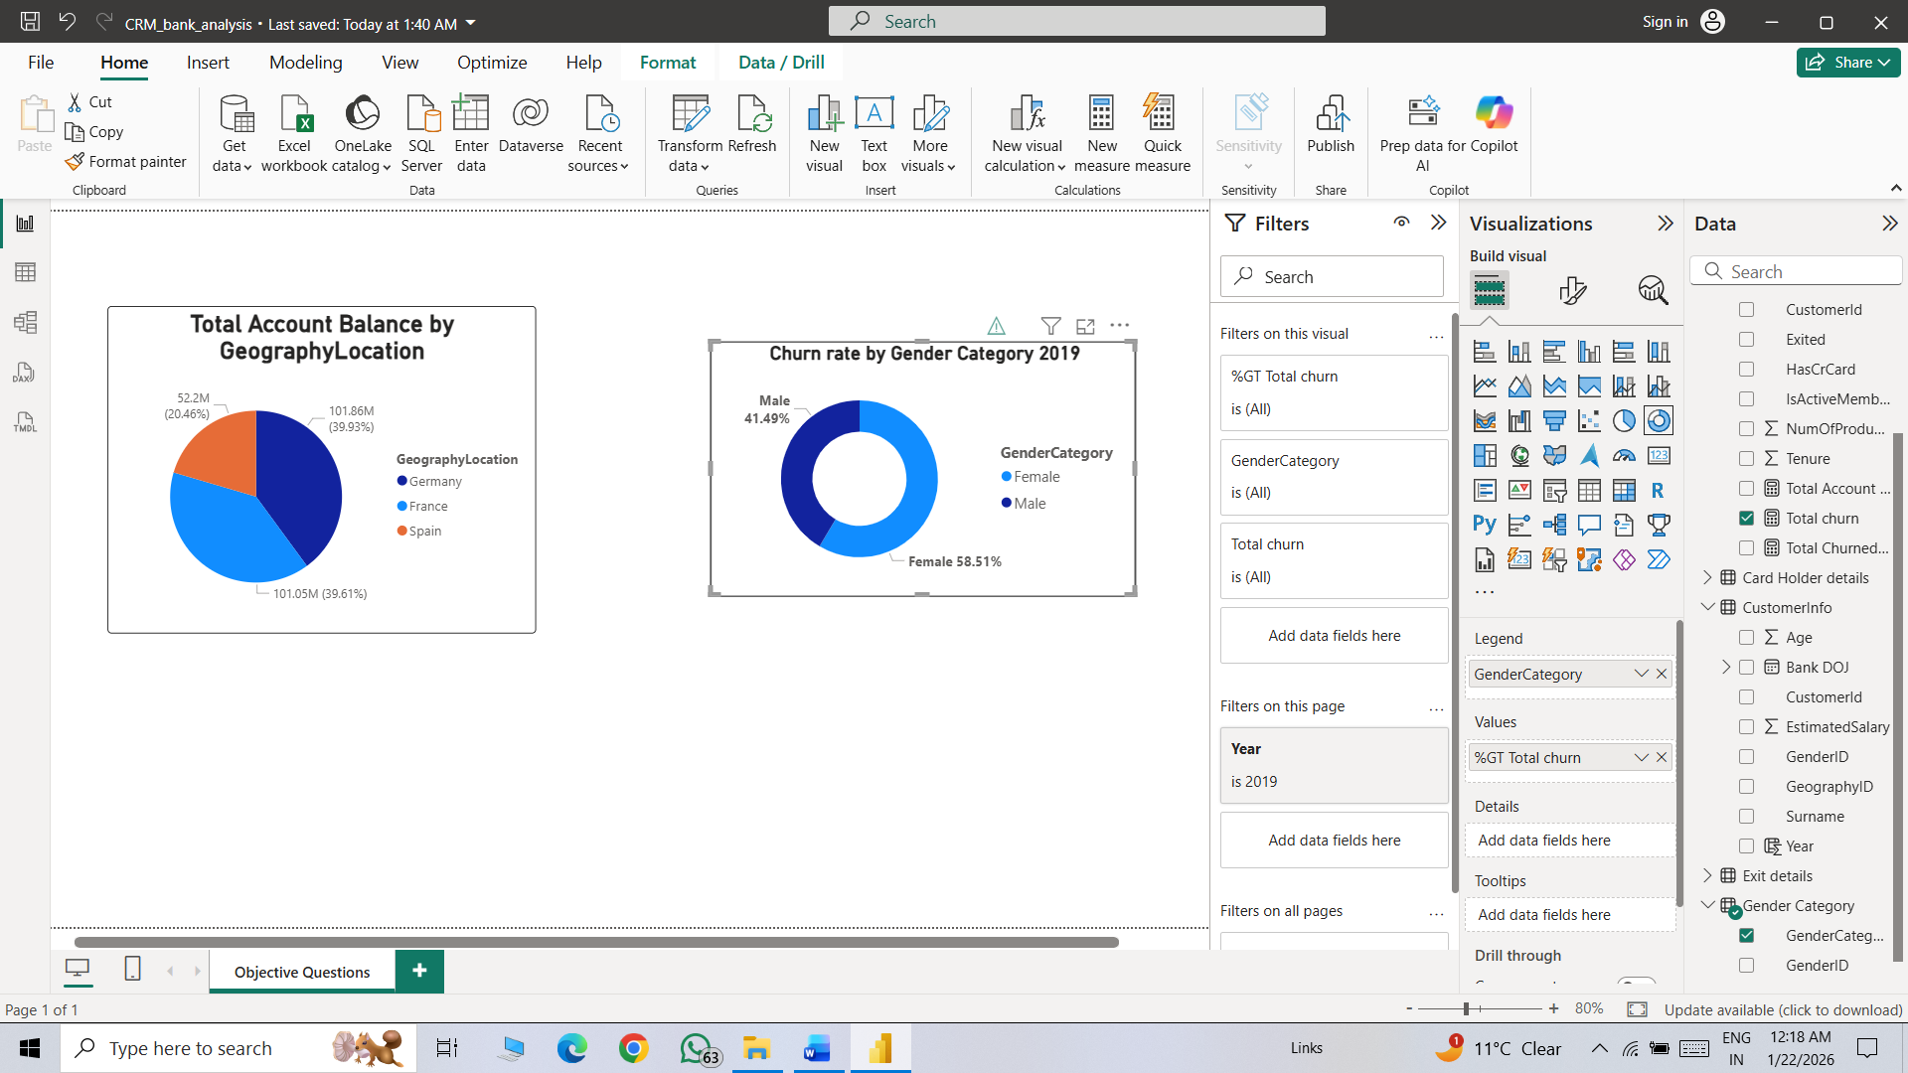

Approach:
- Objective: Determine the churn rate by gender for the most recent year in the dataset.
- Method: To solve this question, we created a DAX measure with the condition IsExited = 1, which represents customers who have left the bank. This allowed us to calculate the total number of churned customers.
Next, we used the Gender Category table to segment the churned customers by gender.
Finally, we visualized the churn distribution by gender using a donut chart to clearly show the proportion of churn between male and female customers.

- Insights: Female customers account for 58.51% of total churn, which is significantly higher than male customers.
Male customers contribute 41.49% of churn, indicating comparatively better retention among males.
- Recommendation: The bank should analyze the specific reasons behind higher churn among female customers (e.g., service issues, product mismatch, pricing) and address those gaps.
Introduce personalized offers and loyalty programs targeted specifically at female customers to improve retention.
Q5. Compare the average credit score of customers who have exited and those who remain. (SQL)
SQL Code:
select Round (Avg(b.creditScore),2) as Avg_creditScore_Exited_customers, Q.Avg_creditScore_remain_customers from customerinfo c
join bank_churn b
on c.customerID = b.customerID
join (
select Round (Avg(b.creditScore),2) as Avg_creditScore_remain_customers from customerinfo c
join bank_churn b
on c.customerID = b.customerID
where b.exited = 0) as Q
group by Q.Avg_creditScore_remain_customers;
- Output: A single table showing
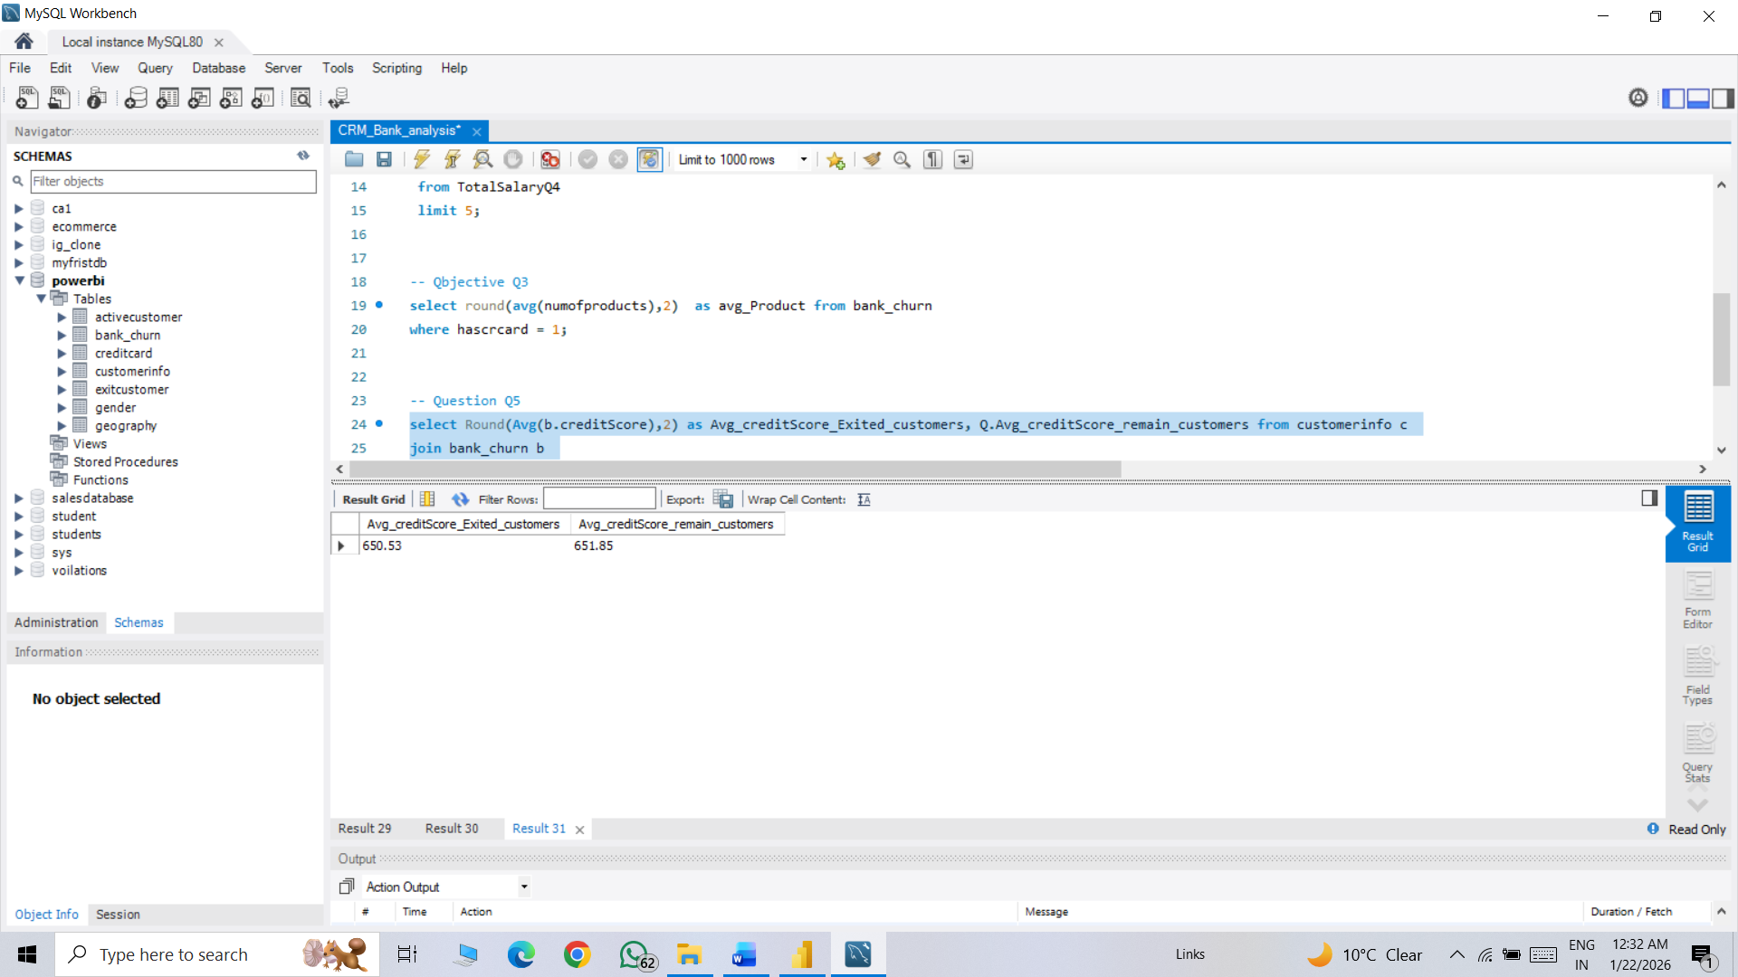

Visualization:

Approach:
- Objective: Compare the average credit score of customers who have exited and those who remain?
Understand customer behavior for before churn and after churn.
- Method: To solve this, we used two tables: Customer Info and Bank_Churn. We applied a subquery along with aggregate functions and joins to calculate the average credit score for both retained customers and exited (churned) customers.
- Insights: The average credit score of remaining customers (651.85) is slightly higher than that of exited customers (650.53).
The difference in credit score is very minimal (around 1–1.5 points), indicating that credit score is not a major factor influencing customer churn.
- Recommendation: Since the credit score difference between exited and retained customers is minimal, the bank should focus more on customer experience, service quality, and product satisfaction rather than relying only on credit score analysis.
Q6. Which gender has a higher average estimated salary, and how does it relate to the number of active accounts? (SQL)
SQL Code:
with Avg_salary as (select G.GenderCategory as Gender,
round (Avg(c.estimatedSalary),2) as Avg_EstimatedSalary
from customerinfo c
join gender g
on c.genderID = g.genderID
where g.genderID = 1
group by G.GenderCategory
union all
select G.GenderCategory as Gender, round (Avg(c.estimatedSalary),2) as Avg_EstimatedSalary
from customerinfo c
join gender g
on c.genderID = g.genderID
where g.genderID = 2
group by G.GenderCategory),
Active_accounts as (select G.GenderCategory as Gender, count(c.customerID) as NumberOFActive_accounts
from customerinfo c
join gender g
on c.genderID = g.genderID
join bank_churn b
on b.customeriD = c.customerID
where b.IsActiveMember = 1 and g.genderID = 1
group by G.GenderCategory
union all

select G.GenderCategory as Gender, count(c.customerID) as NumberOFActive_accounts
from customerinfo c
join gender g
on c.genderID = g.genderID
join bank_churn b
on b.customeriD = c.customerID
where b.IsActiveMember = 1 and g.genderID = 2
group by G.GenderCategory)

select a.gender, a.Avg_EstimatedSalary, a2.NumberOFActive_accounts from Avg_salary a join Active_accounts a2
on a.gender = a2.gender
order by Avg_EstimatedSalary desc
- Output: A single table showing
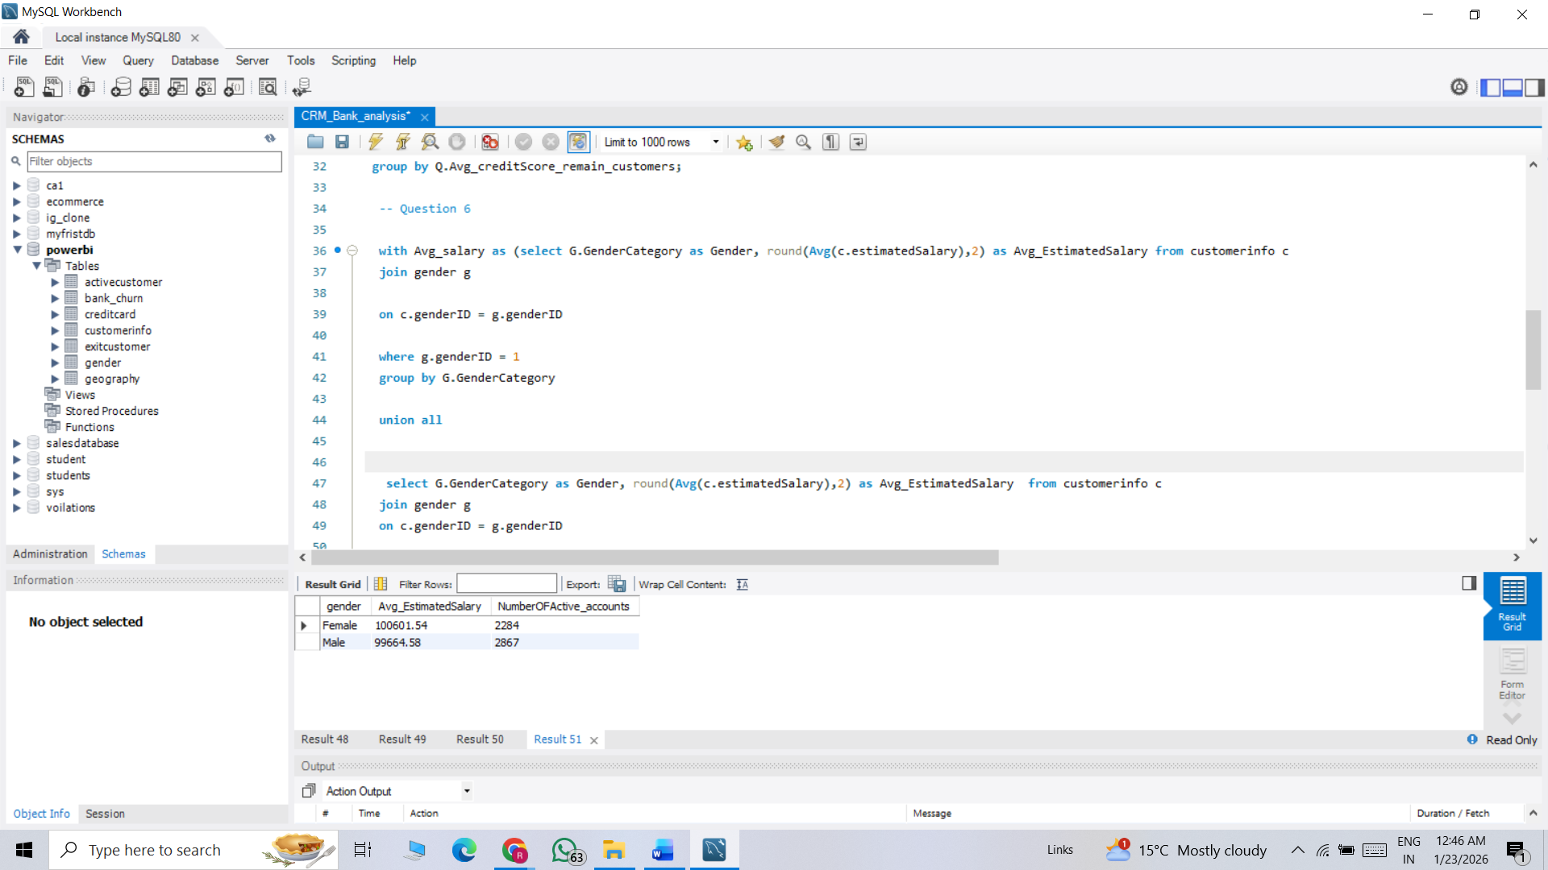
Visualization:

Approach:
- Objective: Which gender has a higher average estimated salary, and how does it relate to the number of active accounts?
- Method: First, we joined the Customer_Info and Gender_Category tables to calculate the average credit score by gender.
Then, we created separate CTEs for each gender to compare their average credit scores more clearly.
After that, we counted the number of active accounts by gender to get an overall understanding of the situation and analyze the broader trend.
- Insights: Female customers have a slightly higher average salary (100,601) compared to male customers (99,664), but the difference is minimal.

Despite similar salary levels, male customers have significantly more active accounts (2,867) compared to female customers (2,284).
This suggests that even though female customers earn slightly more on average, males show higher account activity or engagement with the bank
- Recommendation: Maintain strong engagement strategies for male customers, as they currently show higher account activity and contribute significantly to overall engagement.

Q7. Segment the customers based on their credit score and identify the segment with the highest exit rate. (SQL)
SQL Code:
with Segments as (select c.customerID,
b.creditScore,
(Case when b.creditScore>750 then "Excellent"
when b.creditScore between 700 and 750 then "Very Good"
when b.creditScore between 600 and 700 then "Average"
when b.creditScore<600 then "Poor"
end) as CreditCategory,
b.Exited
from customerinfo c
join bank_churn b
on b.customerID = c.customerID ),

ExitedCustomer as (select CreditCategory,count(customerID) as Total_LeftCustomers from segments
where Exited = 1
group by CreditCategory)

select distinct e.CreditCategory,round(e.Total_LeftCustomers/ (select count(customerID) as Total_customer from bank_churn) *100,2) as Exit_rate from Segments s
join ExitedCustomer e
on s.creditCategory=s.creditcategory
order by Exit_rate desc
- Output: A single table showing
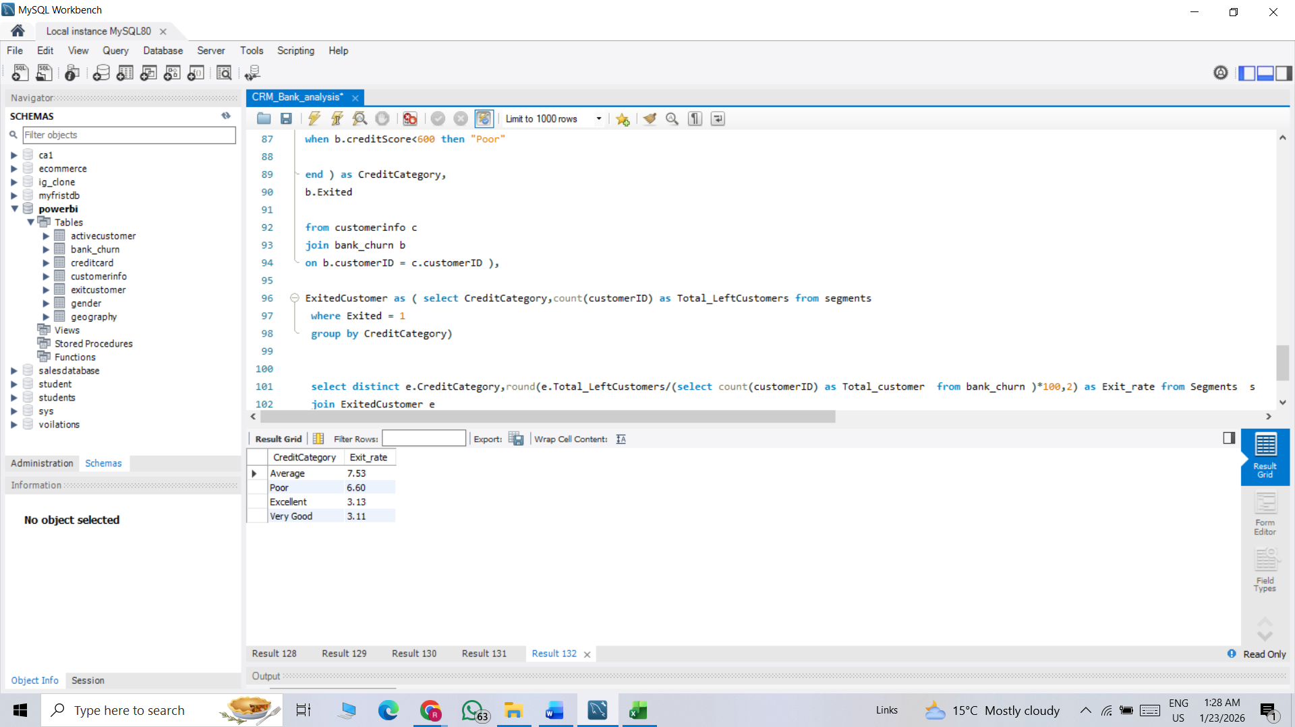
Visualization:

Approach:
- Objective: Segment the customers based on their credit score and identify the segment with the highest exit rate?
- Method: We applied CASE WHEN conditions to categorize customers into different credit score ranges. After creating these categories, we used a CTE, along with aggregate functions and joins, to count the number of customers which is exit falling into each credit score category.
- Insights: Customers with Average credit scores have the highest exit rate (7.53%), followed by Poor credit score customers (6.6%).
Customers with Excellent (3.13%) and Very Good (3.11%) credit scores have significantly lower churn rates.
This indicates that customers in the mid-to-low credit score range are more likely to leave the bank compared to high credit score customers
- Recommendation: The bank should focus on retention strategies for Average and Poor credit score customers, as they show the highest exit rates.

Q8. Find out which geographic region has the highest number of active customers with a tenure greater than 5 years. (SQL)
SQL Code:
select g.GeographyLocation,count(c.customerID) as NumberOF_Active_User from customerinfo c
join geography g
on g.geographyID = c.geographyID
join bank_churn b
on c.customerID = b.customerID
where b.IsActiveMember=1 and b.tenure>5
group by g.GeographyLocation
order by NumberOF_Active_User desc;
- Output: A single table showing
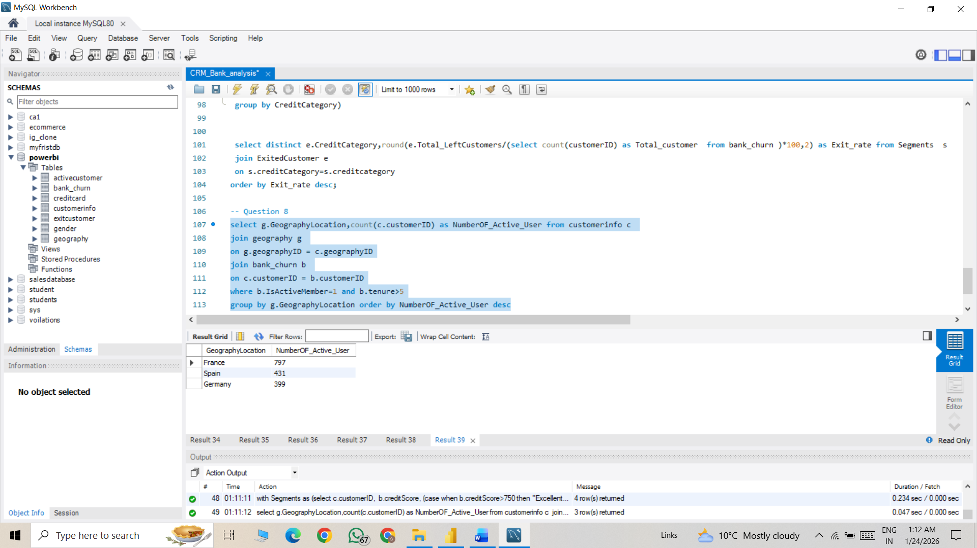
Visualization:

Approach:
- Objective: Find out which geographic region has the highest number of active customers with a tenure greater than 5 years identify which area have highest number of loyal customers?
- Method: To solve this question, we joined three tables: Customer_Info, Bank_Churn, and Geographical_Locations.
We then applied the conditions IsExited = 0 (customers who have not left the bank) and Tenure > 5 years to filter long-term retained customers.
Finally, we counted the number of customers who met these conditions to understand the distribution of loyal, long-tenure customers across different regions.
- Insights:
  - France has the highest number of active long-tenure customers (797), indicating strong customer retention in this region.
  - Spain has 431 active customers, showing moderate retention performance.
  - Germany has the lowest count (399) among the three regions, suggesting comparatively lower long-term customer retention.
- Recommendation: Since France has the highest number of loyal, long-tenure customers, the bank should maintain strong relationship management and introduce loyalty rewards programs to retain this valuable segment.

Q9. What is the impact of having a credit card on customer churn, based on the available data?
Visualization:

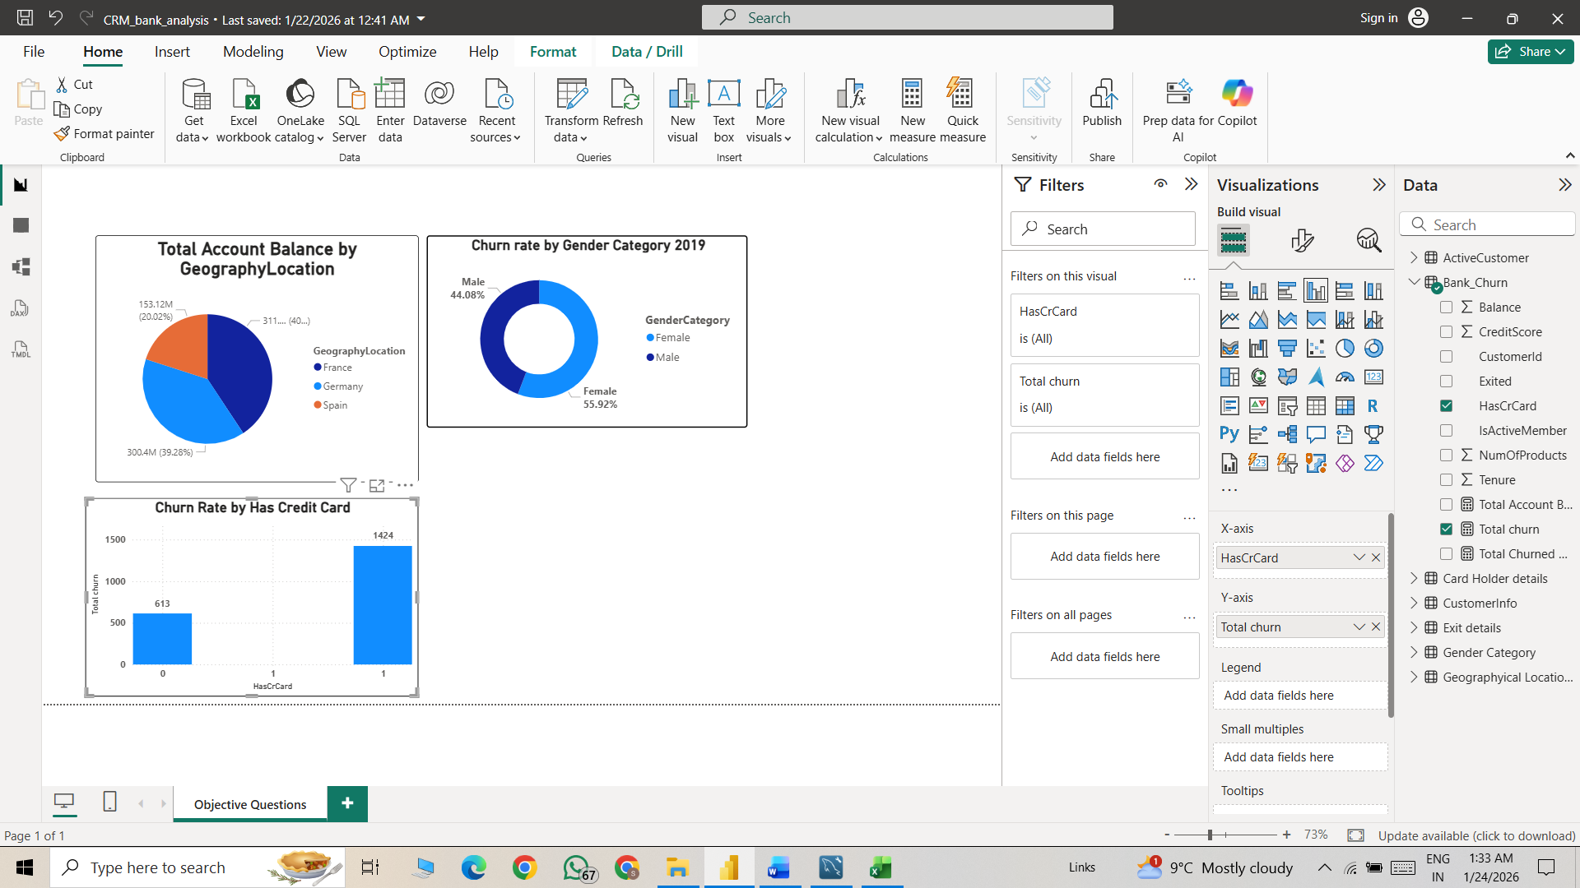

Approach:
- Objective: What is the impact of having a credit card on customer churn, based on the available data?
- Method: We created a DAX measure to calculate the total number of churned customers.
  - Then, we applied a filter on the HasCreditCard column to analyze churn based on whether customers had a credit card or not.
  - This helped us evaluate which group of customers (credit card holders vs. non-credit card holders) had a higher churn rate.
- Insights: Customers who have a credit card (1) show significantly higher churn (1424 customers) compared to those who do not have a credit card (0) with 613 customers.
This suggests that credit card holders are leaving the bank more frequently than non-credit card holders.
- Recommendation: The bank should analyse credit card-related issues such as high fees, interest rates, reward structure, or customer service problems that may be driving higher churn among cardholders.

Q10. For customers who have exited, what is the most common number of products they have used?
Visualization:
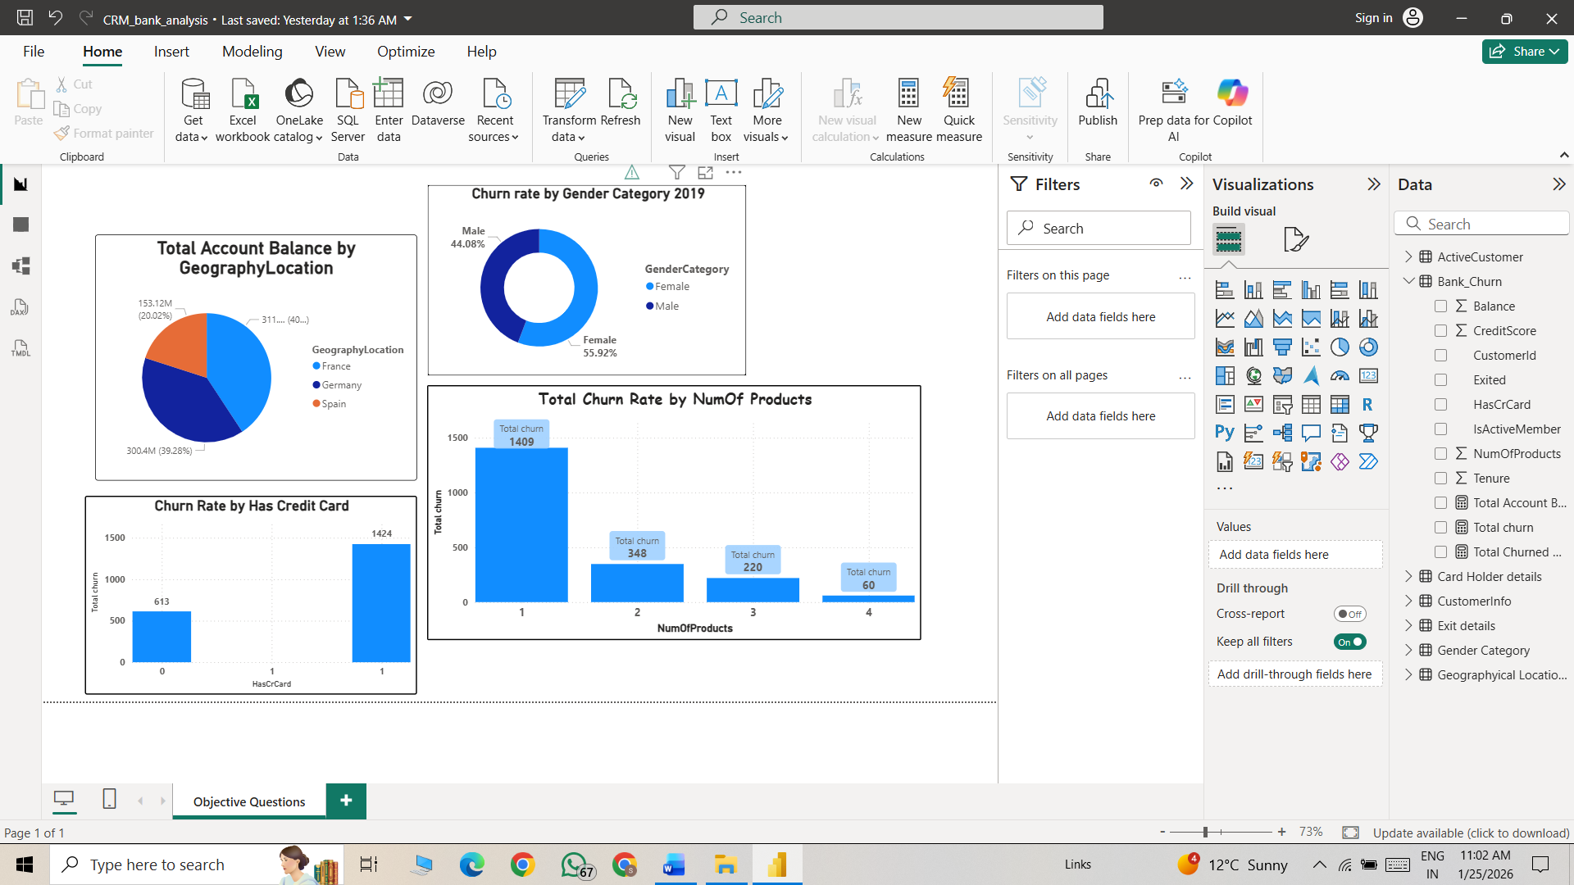

Approach:
- Objective: For customers who have exited, what is the most common number of products they have used?
- Method: Using the total number of churned customers, we categorized them based on the number of products they were using.
This helped us analyze how product holding impacts customer churn and identify which product segments have higher exit rates.
- Insights:
  - Customers with only 1 product have the highest churn (1409 customers), which is significantly higher than other segments.
  - Churn decreases as the number of products increases — customers with 2, 3, or 4 products show much lower churn.
  - Customers holding 4 products have the lowest churn (60 customers), indicating that higher product engagement leads to better retention.

- Recommendation: Implement targeted engagement campaigns for single-product customers, as they represent the highest churn-risk segment.

Q11. Examine the trend of customers joining over time and identify any seasonal patterns (yearly or monthly). Prepare the data through SQL and then visualize it.
SQL Code:
select DATE_FORMAT (bank_DOJ,"%M”) as MonthOfJoining,
Year(bank_DOJ) as YearOfJoining,
Quarter (Bank_DOJ) as CurrentQuarter,
count(customerId) as NumberOfJoining
from customerinfo
group by MonthOfJoining, YearOfJoining, CurrentQuarter order by YearOfJoining asc, CurrentQuarter asc
- Output: A single table showing
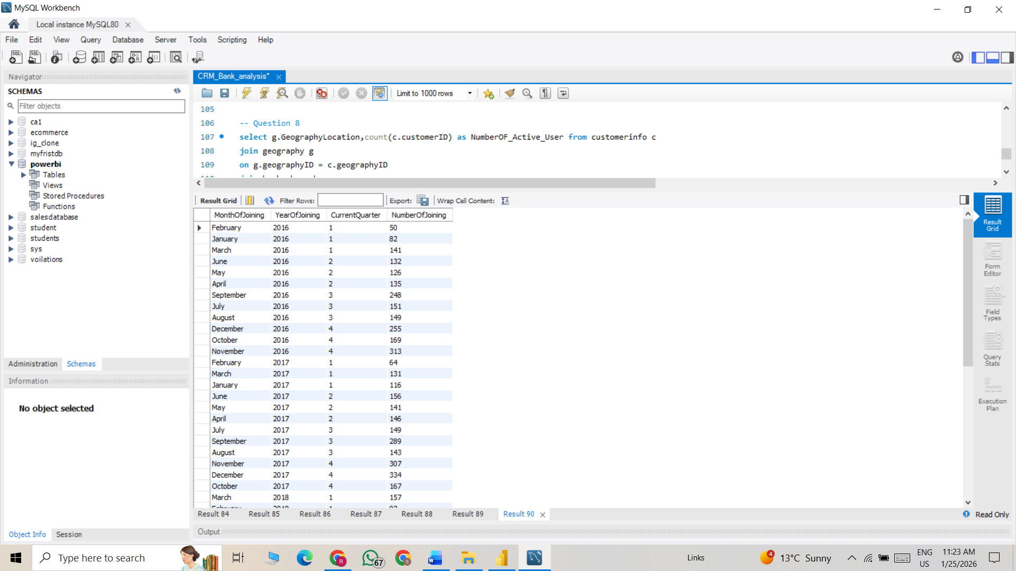
Visualization:

Approach:
- Objective:
. Examine the trend of customers joining over time and identify any seasonal patterns (yearly or monthly). Prepare the data through SQL and then visualize it.

- Method:
  - To solve this question, we used the Customer_Info table and applied date functions to calculate the number of customers who joined the bank each month.
  - Similarly, we performed a yearly aggregation to analyze the number of customers joinings per year.
  - This helped us understand the monthly and yearly customer acquisition trends of the bank.
- Insights:
  - Consistent Growth Year over Year
    - 2016: 1,951 customers
    - 2017: 2,143 customers (~10% growth)
    - 2018: 2,593 customers (~21% growth)
    - 2019: 3,313 customers (~28% growth)
- The largest jump occurred between 2018 and 2019.
Overall growth from 2016 to 2019 is approximately 70%, indicating effective scaling and customer acquisition strategies.
Peak Months:
- November (1,437) – Highest
- December (1,409)
- September (1,356)
Lowest Months:
- February (324) – Lowest
- January (482)

Recommendation:
February (324) and January (482) are significantly lower than other months.
- Launch New Year acquisition campaigns
- Offer limited-time sign-up incentives
- Introduce referral bonuses in Q1

Q12. Analyze the relationship between the number of products and the account balance for customers who have exited.
Visualization:
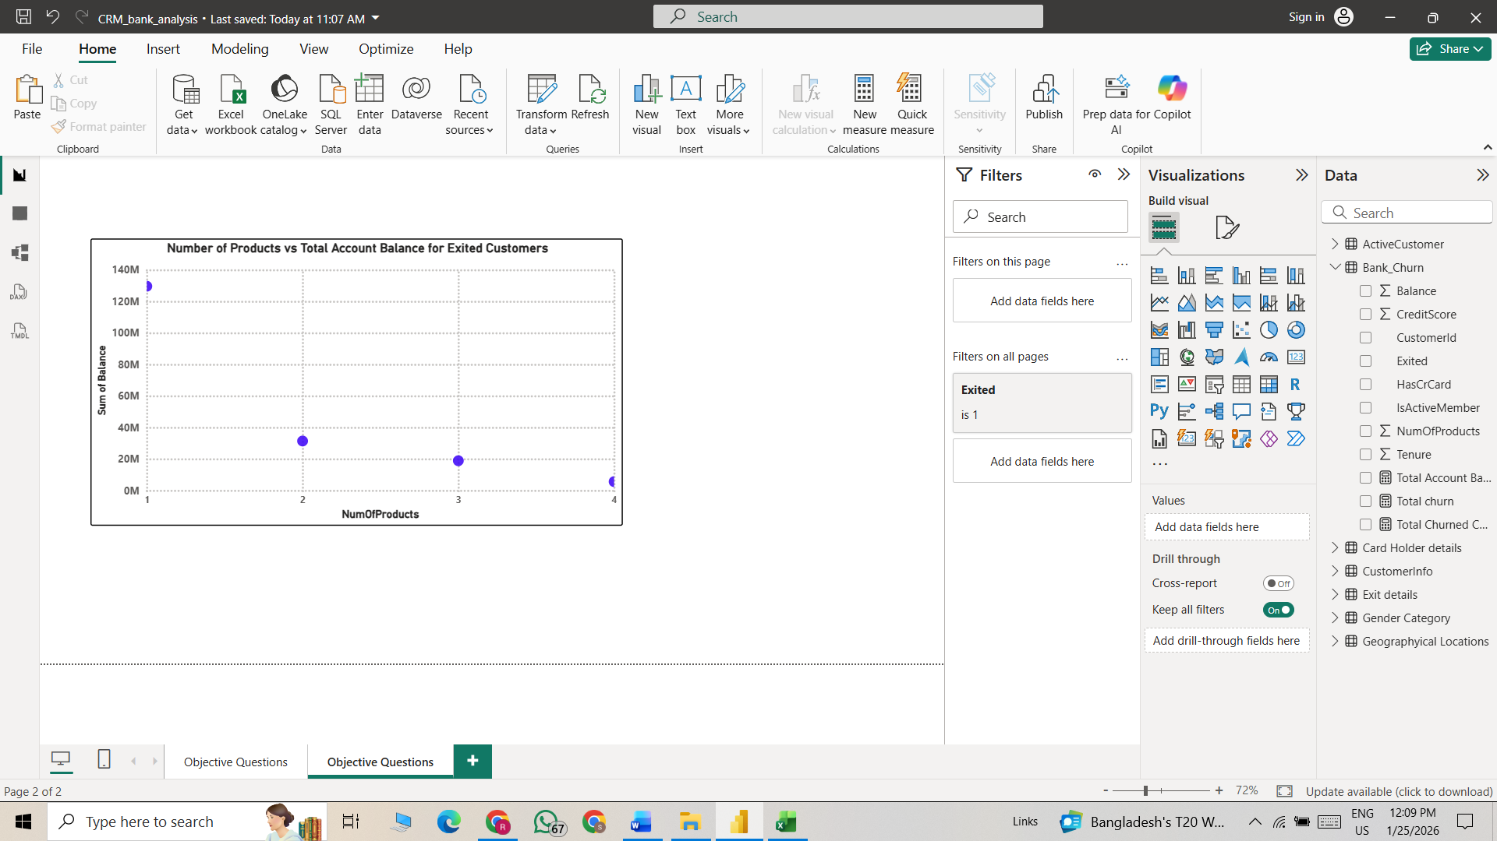

Approach:
- Objective: Analyze the relationship between the number of products and the account balance for customers who have exited.
- Method: To solve this question, I used the Number of Products columns along with the Total Account Balance.
In the report view, I created a scatter chart to visualize the relationship between the number of products a customer holds and their total account balance.

- Insights:
- Exited customers with only 1 product hold the highest total account balance, indicating that a large amount of money is lost from single-product customers.
- As the number of products increases, the total exited balance decreases significantly, showing lower churn impact from multi-product customers.
- Customers with 3 or 4 products contribute very little to the exited balance, suggesting that higher product engagement improves retention.
- Recommendation: The bank should focus strongly on single-product customers with high balances, as they represent the highest financial loss when they churn. Personalized retention strategies and relationship management should be prioritized for this segment.

Q13. Identify any potential outliers in terms of balance among customers who have remained with the bank.
Visualization:
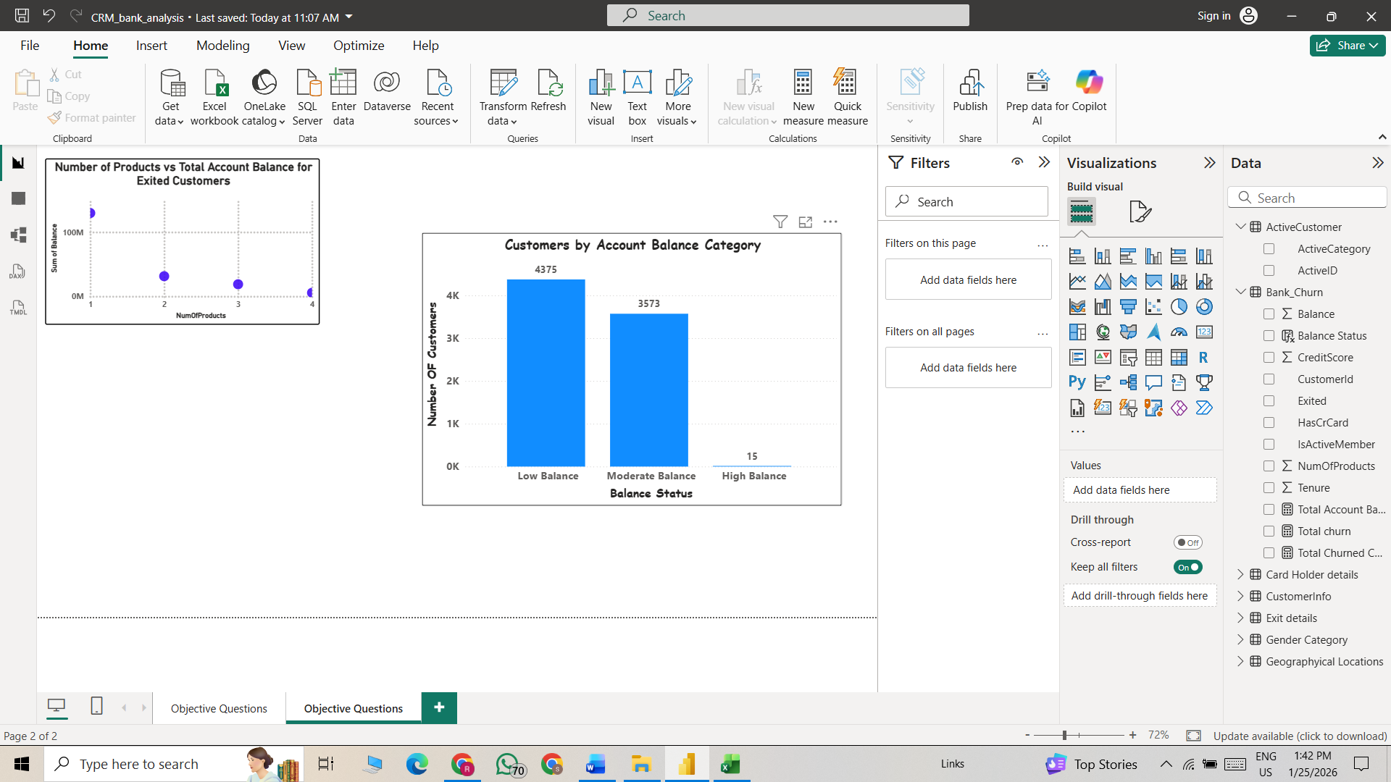
Approach:
- Objective: Identify any potential outliers in terms of balance among customers who have remained with the bank.
- Method: Here, we used IF–ELSE conditions to create an Account Balance Status category, considering only customers who are still active.
  - The conditions were defined as:
  - High Balance: Balance ≥ 200,000
  - Moderate Balance: Balance between 100,001 and 199,999
  - Low Balance: Balance ≤ 100,000
After categorizing the customers, we counted how many active customers fall into each balance category to understand the distribution of account balances among retained customers.

- Insights: The majority of active customers fall into the Low Balance category (4,375 customers), indicating that most customers maintain relatively smaller account balances.
A significant number of customers are in the Moderate Balance category (3,573 customers), showing a stable mid-value segment.
Only 15 customers are in the High Balance category, highlighting a very small premium segment within the bank.
- Recommendation: Since most customers fall into the Low Balance category, the bank should introduce savings incentives, investment plans, and financial awareness programs to encourage higher deposits.

Q14. How many different tables are given in the dataset, out of these tables which table only consists of categorical variables?
In the given dataset there are total 7 tables out of 5 tables are only consists of categorical variables e.g. (ActiveCustomer Category, Cardholder Category, exit details Category, Gender Category, Geographical Location Category) these are 5 tables and other 2 tables are one fact table and other one is dimension table e.g. (Customerinfo – Dimension Table, Bank_churn - Fact table).

Q15. Using SQL, write a query to find out the gender-wise average income of males and females in each geography id. Also, rank the gender according to the average value. (SQL)
SQL Code:
with AverageINcome as (select
g.genderCategory,
gh.GeographyLocation,
round(Avg(c.estimatedSalary),2) as Average_Salary
from customerInfo c
join gender g
on g.genderID = c.genderID
join geography gh
on gh.geographyID = c.geographyID
group by g.genderCategory, gh.GeographyLocation)
select GenderCategory,GeographyLocation,Average_Salary,
rank() over(partition by GenderCategory order by Average_Salary desc) as "Rank"
from AverageINcome
- Output: A single table showing
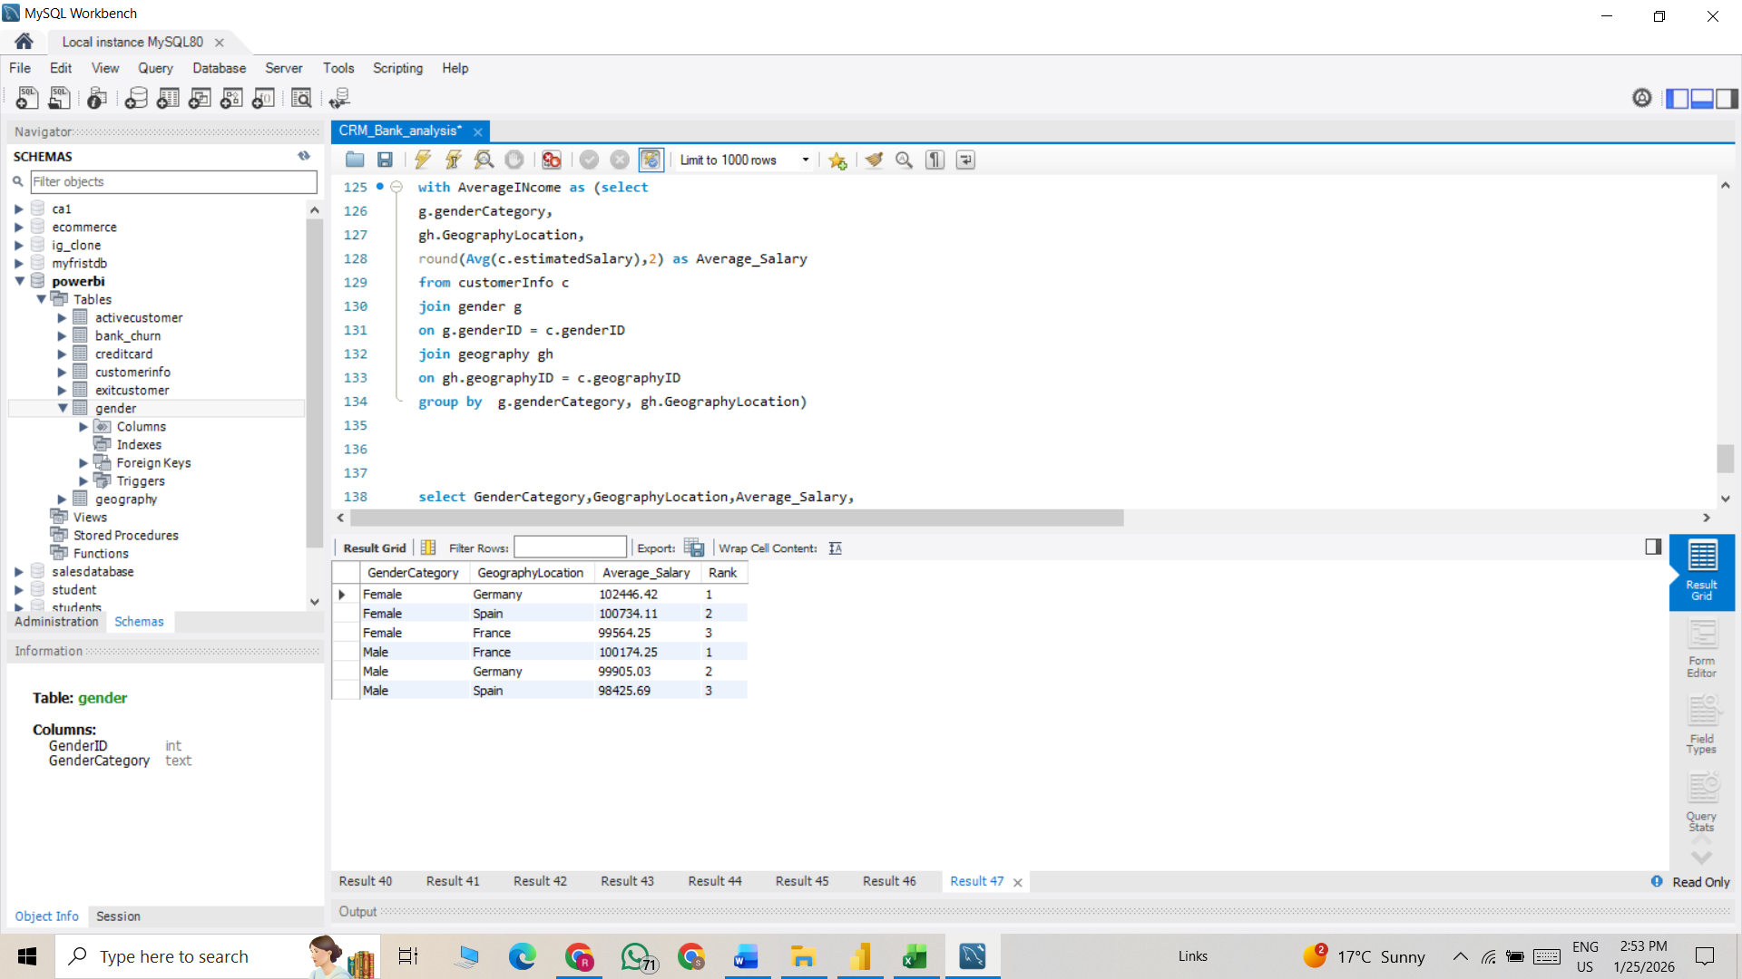
Visualization:

Approach:
- Objective:
- write a query to find out the gender-wise average income of males and females in each geography id. Also, rank the gender according to the average value
- Method:
  - To solve this, we joined three tables: Customer_Info, Gender, and Geography_Locations.
  - After joining the tables, we applied aggregate functions to calculate the average Estimated Salary based on both geographical location and gender.
  - Finally, we ranked the results in descending order to identify which region and gender group has the highest average estimated salary.

- Insights:
- Germany stands out as the strongest market in terms of average estimated salary. Both male and female customers in Germany earn more on average compared to the other two locations.
- Spain holds the middle position. The average salaries are lower than Germany but generally higher than France (especially for female customers). Spain can be considered a moderately strong market with stable earning potential.
- France ranks lowest overall in average estimated salary among the three countries. Although the difference is not extremely large, France consistently appears below Germany and slightly below Spain in salary averages.

- Recommendation:
  - Focus on premium and wealth products in Germany, as it has the highest earning customers.
  - Use growth and cross-selling strategies in Spain to increase customer value.
Q16. Using SQL, write a query to find out the average tenure of the people who have exited in each age bracket (18-30, 30-50, 50+).
SQL Code:
select
(Case when c.age between 18 and 30 then "18-30"
when c.age between 30 and 50 then "30-50"
when c.age>50 then "50+"
end
) As Age_Group,
round(avg(b.tenure),2) as Avg_Tenure
from bank_churn b
join customerinfo c
on b.customerID = c.customerID
where b.exited = 1
group by Age_group order by Age_group asc
- Output: A single table showing
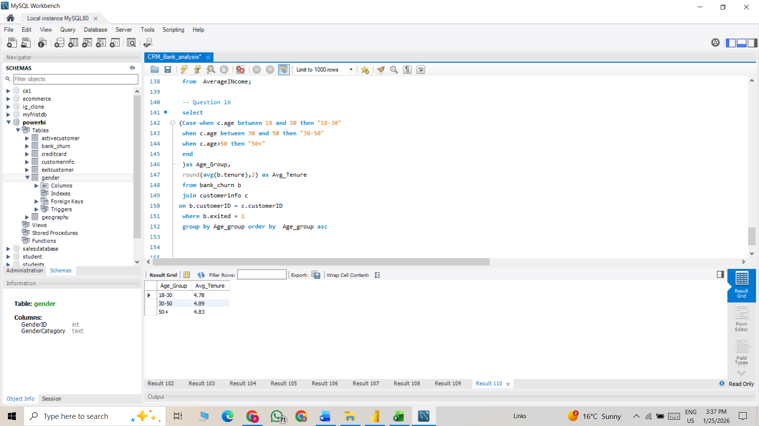

Visualization:

Approach:
- Objective:
  - Using SQL, write a query to find out the average tenure of the people who have exited in each age bracket (18-30, 30-50, 50+).

- Method: To solve this question, we first joined two tables in the MySQL interface, namely Customer_Info and Bank_Churn. Then, we applied a CASE WHEN statement to create age buckets. Finally, we calculated the average tenure of customers in the bank.
- Insights:
  - Customers aged 30–50 have the highest average tenure (4.89 years), indicating they are the most stable and long-term customers of the bank.
  - The 50+ age group has a slightly lower average tenure (4.83 years), but still remains relatively loyal compared to younger customers.
  - The 18–30 age group has the lowest average tenure (4.78 years), suggesting younger customers are slightly more likely to switch banks or have shorter banking relationships.
- Recommendation: Focus on retention strategies for the 18–30 age group, such as digital banking features, rewards programs, and personalized offers to increase long-term loyalty.
Q17. Is there any direct correlation between salary and the balance of the customers? And is it different for people who have exited or not?
Account Balance and Estimated Salary appear to be largely independent, showing no direct linear relationship
Visualization:
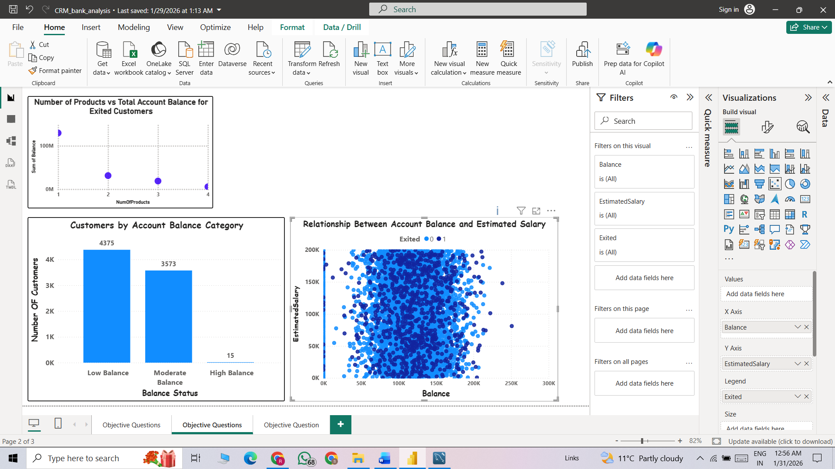

Approach:
- Objective:
  - Is there any direct correlation between salary and the balance of the customers? And is it different for people who have exited or not?
- Method: To solve this question, we selected two columns-Account Balance and Estimated Salary-from the Customer_Info and Bank_Churn tables, and used a scatter chart to visualize the relationship between them.
- Insights: There is no strong visible correlation between account balance and estimated salary. Customers with both high and low salaries appear across all balance ranges.
Customers with zero balance are present across different salary levels, indicating that salary alone does not determine whether customers maintain funds in their accounts. Based on the scatter plot, there is no clear visual difference between customers who exited and those who stayed. Both exited (1) and non-exited (0) customers are spread across all salary and balance ranges.
Q18. Is there any correlation between the salary and the Credit score of customers?
Visualization:
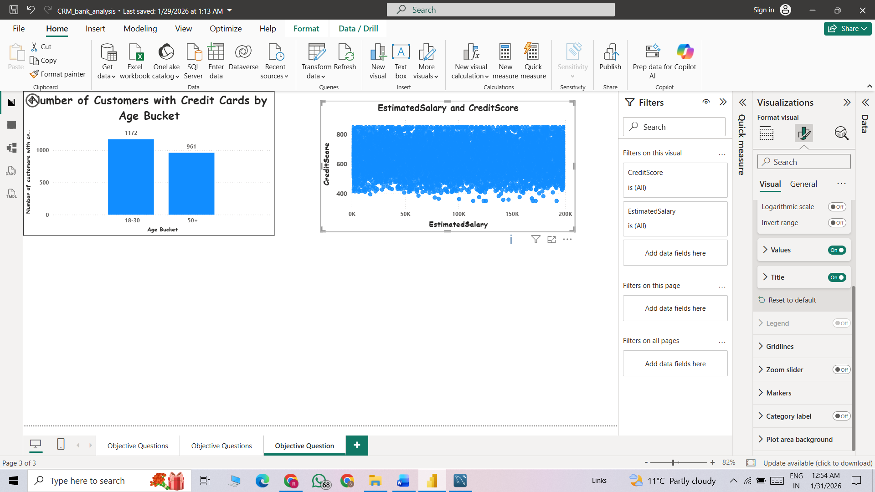
Approach:
- Objective: Is there any correlation between the salary and the Credit score of customers?
- Method: To solve this question, we used a scatter plot in the report view to represent the relationship between Estimated Salary and Credit Score, using the Estimated_Salary and CreditScore columns.
- Insights:
  - There is no strong correlation between estimated salary and credit score. Customers with both high and low salaries have a wide range of credit scores.
  - Credit scores are spread mostly between 400 and 850, regardless of salary level. This indicates income does not directly determine creditworthiness.

Q19. Rank each bucket of credit score as per the number of customers who have churned the bank.
Visualization:

Approach:
- Objective: Rank each bucket of credit score as per the number of customers who have churned the bank.
- Method: In the table view, we created a calculated column to define Credit Categories based on specific conditions. Then, we calculated the average exit rate for each credit category and ranked them according to the exit.
- Insights:
- The chart shows that churn is highest among customers with Average and Poor credit scores, while customers with Excellent and Very Good credit scores have much lower churn rates. This indicates that lower and mid-credit customers are more likely to leave the bank.
- Recommendation: The bank should focus on retaining Average and Poor credit customers by offering flexible repayment options, personalized offers, and better communication. Early identification of at-risk customers and targeted loyalty benefits can help reduce churn.

Q20. According to the age buckets find the number of customers who have a credit card. Also retrieve those buckets that have lesser than average number of credit cards per bucket.
The Average Number of credit card per category is 2351.3 so here we include only age bucket having average less than 2351.

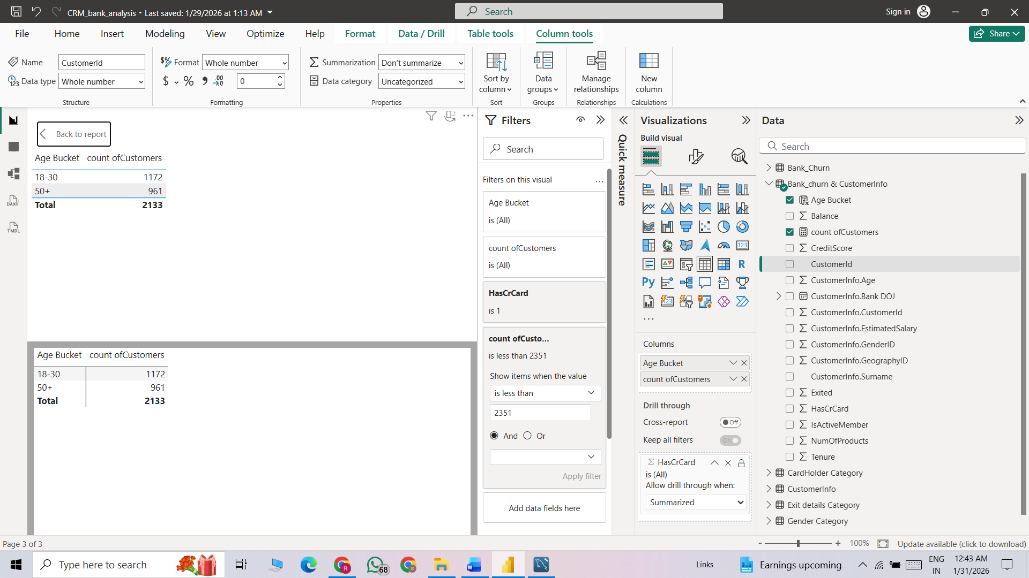
Visualization:
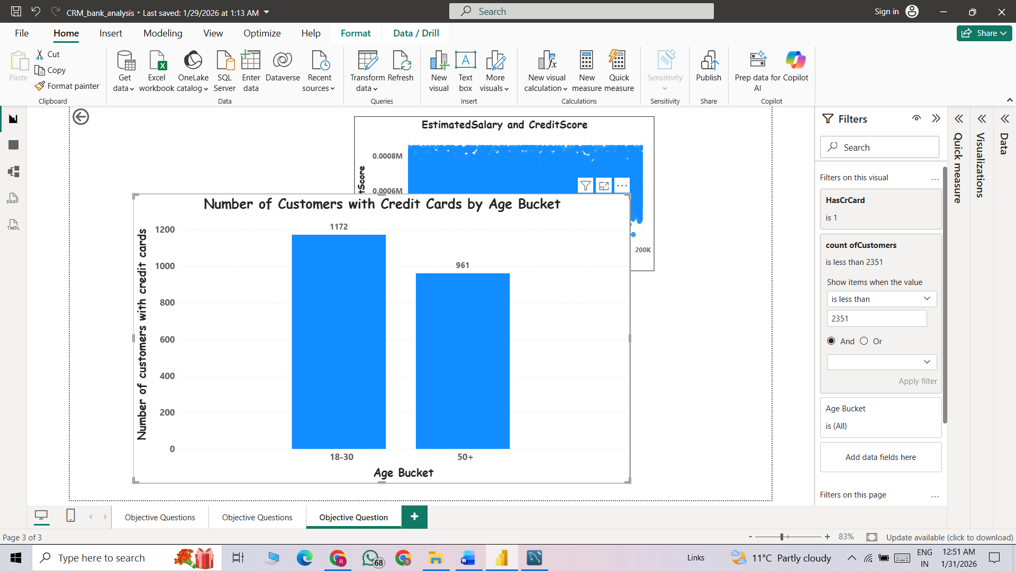
Approach:
- Objective: According to the age buckets find the number of customers who have a credit card. Also retrieve those buckets that have lesser than average number of credit cards per bucket.
- Method: To solve this question, we first created two age groups: 18–30 and 50+. Then, in the report view, we calculated and displayed the number of customers falling into each of these age categories to compare their distribution.
- Insights: The chart shows that customers aged 18–30 have a higher number of credit cards (1172) compared to customers aged 50+ (961). This indicates that younger customers are more likely to use or adopt credit cards than older customer
- Recommendation: The bank should strengthen its focus on the 18–30 segment by offering digital-first benefits such as cashback, EMI options, and rewards for online spending, since this group already shows high credit card usage.

Q21. Rank the Locations as per the number of people who have churned the bank and average balance of the customers.
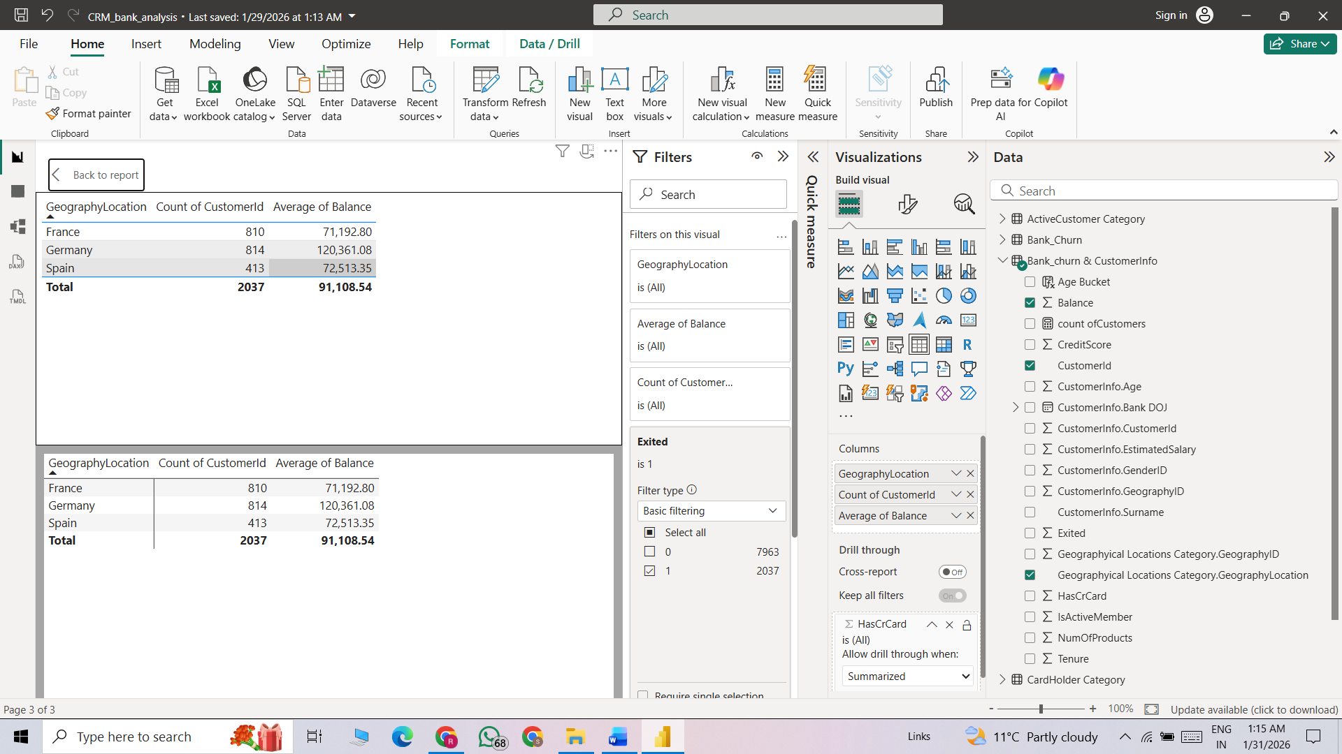
Visualization:
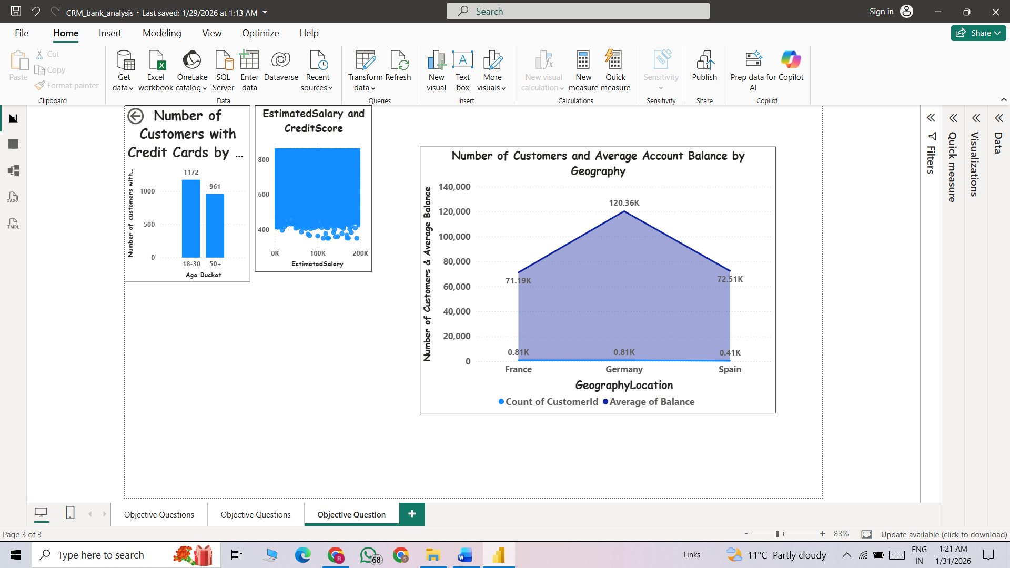
Approach:
- Objective: Rank the Locations as per the number of people who have churned the bank and average balance of the customers.
- Method: To solve this question, we used two tables, customer_info and bank_churn, and joined them based on the customer ID. Then we filtered customers where Exited = 1 to identify those who left the bank. After that, we calculated the average balance and the count of exited customers for each location. Finally, we ranked the locations based on the number of exited customers and their average balance to identify which regions had higher churn impact.
- Insights:
  - The chart shows that Germany has the highest average account balance at around 120.36K, significantly higher than France (71.19K) and Spain (72.51K). This indicates that customers in Germany maintain much larger balances compared to the other two countries.
  - In terms of customer count, France and Germany have a similar number of customers (around 0.81K each), while Spain has the lowest (0.41K). Even though Germany and France have nearly the same customer base, Germany contributes much higher value per customer due to its higher average balance.
- Recommendation:
  - For France, the focus can be on increasing average balance through cross-selling savings plans, fixed deposits, and personalized offers.
  - In Spain, the bank should work on customer acquisition strategies and engagement campaigns to grow the customer base and improve overall account balance

Q22. As we can see that the “CustomerInfo” table has the CustomerID and Surname, now if we have to join it with a table where the primary key is also a combination of CustomerID and Surname, come up with a column where the format is “CustomerID_Surname”.

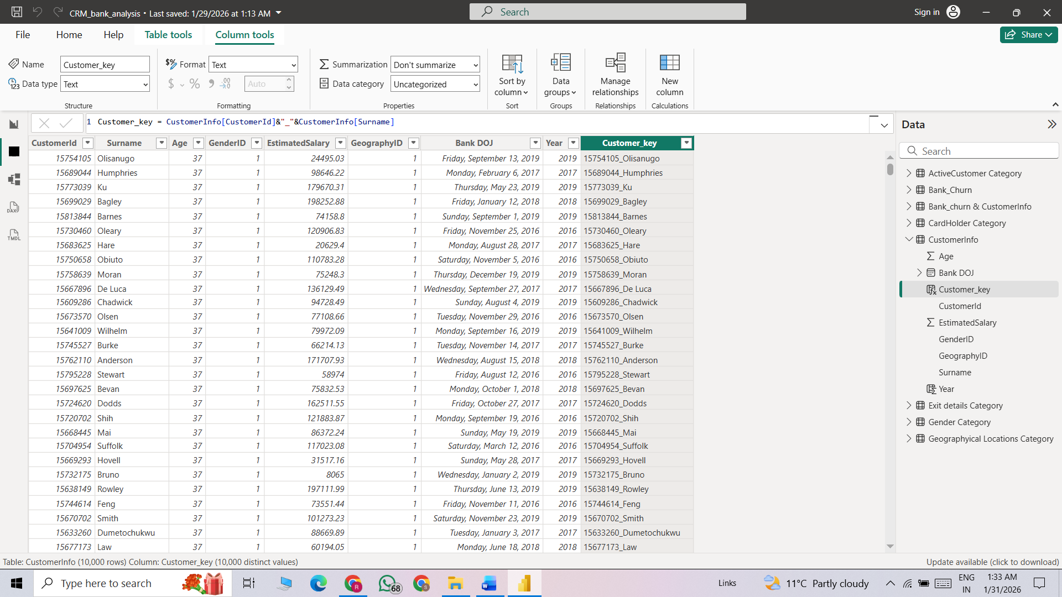
Approach:
- Objective: As we can see that the “CustomerInfo” table has the CustomerID and Surname, now if we have to join it with a table where the primary key is also a combination of CustomerID and Surname, come up with a column where the format is “CustomerID_Surname”.
- Method: We achieve this task using concat function here we join 2 columns customerID and customerName together by add new column in table view.
  - Dax is Customer_key = CustomerInfo[CustomerId]&"_"&CustomerInfo[Surname]

Q23. Without using “Join”, can we get the “ExitCategory” from ExitCustomers table to Bank_Churn table? If yes do this using SQL.
SQL Code:
SELECT *,
(SELECT ec.ExitCategory
FROM exitcustomer ec
WHERE ec.ExitID = bank_churn.Exited
) AS ExitCategory
FROM bank_churn;
- Output: A single table showing
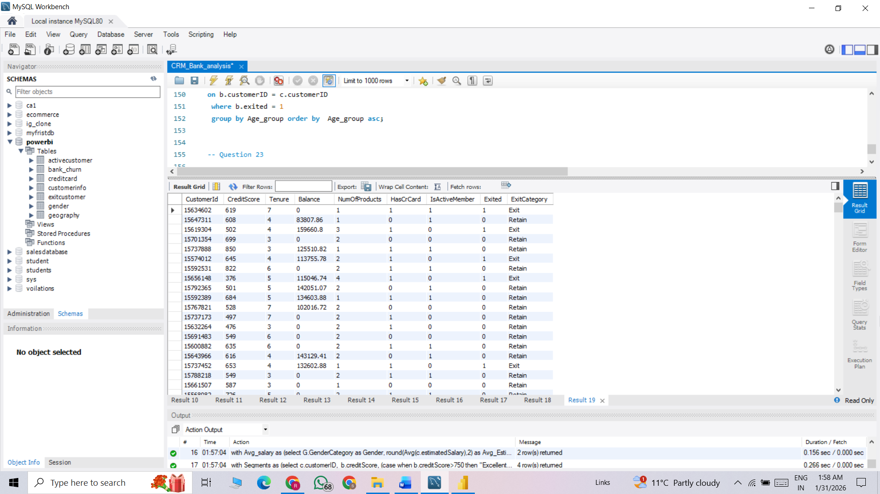
Approach:
- Objective: Without using “Join”, can we get the “ExitCategory” from ExitCustomers table to Bank_Churn table? If yes do this using SQL.
- Method: Yes, we can retrieve exited customers from bank_churn without using an explicit JOIN by applying the subquery concept. Instead of joining tables, we use a subquery to filter or fetch the required records (for example, selecting customers where Exited = 1) and then use that result in the main query. This allows us to achieve the same outcome as a join while keeping the logic inside a nested query.
Q24. Were there any missing values in the data, using which tool did you replace them and what are the ways to handle them?
In the given dataset, there are no missing or blank values; all seven tables are complete. However, if missing values are encountered in the future, they can be handled using the following approaches:
- In the Power Query Editor, the Remove Rows option can be used to eliminate blank records by selecting Remove Blank Rows.
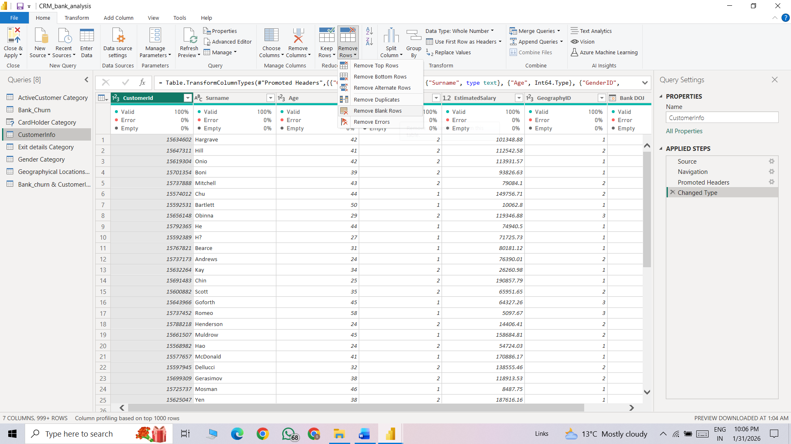
2. Alternatively, by right-clicking on a column and selecting Replace Values, missing entries can be replaced with meaningful placeholders such as Not Available (N/A) or Unknown to ensure better interpretation and insights from the dataset.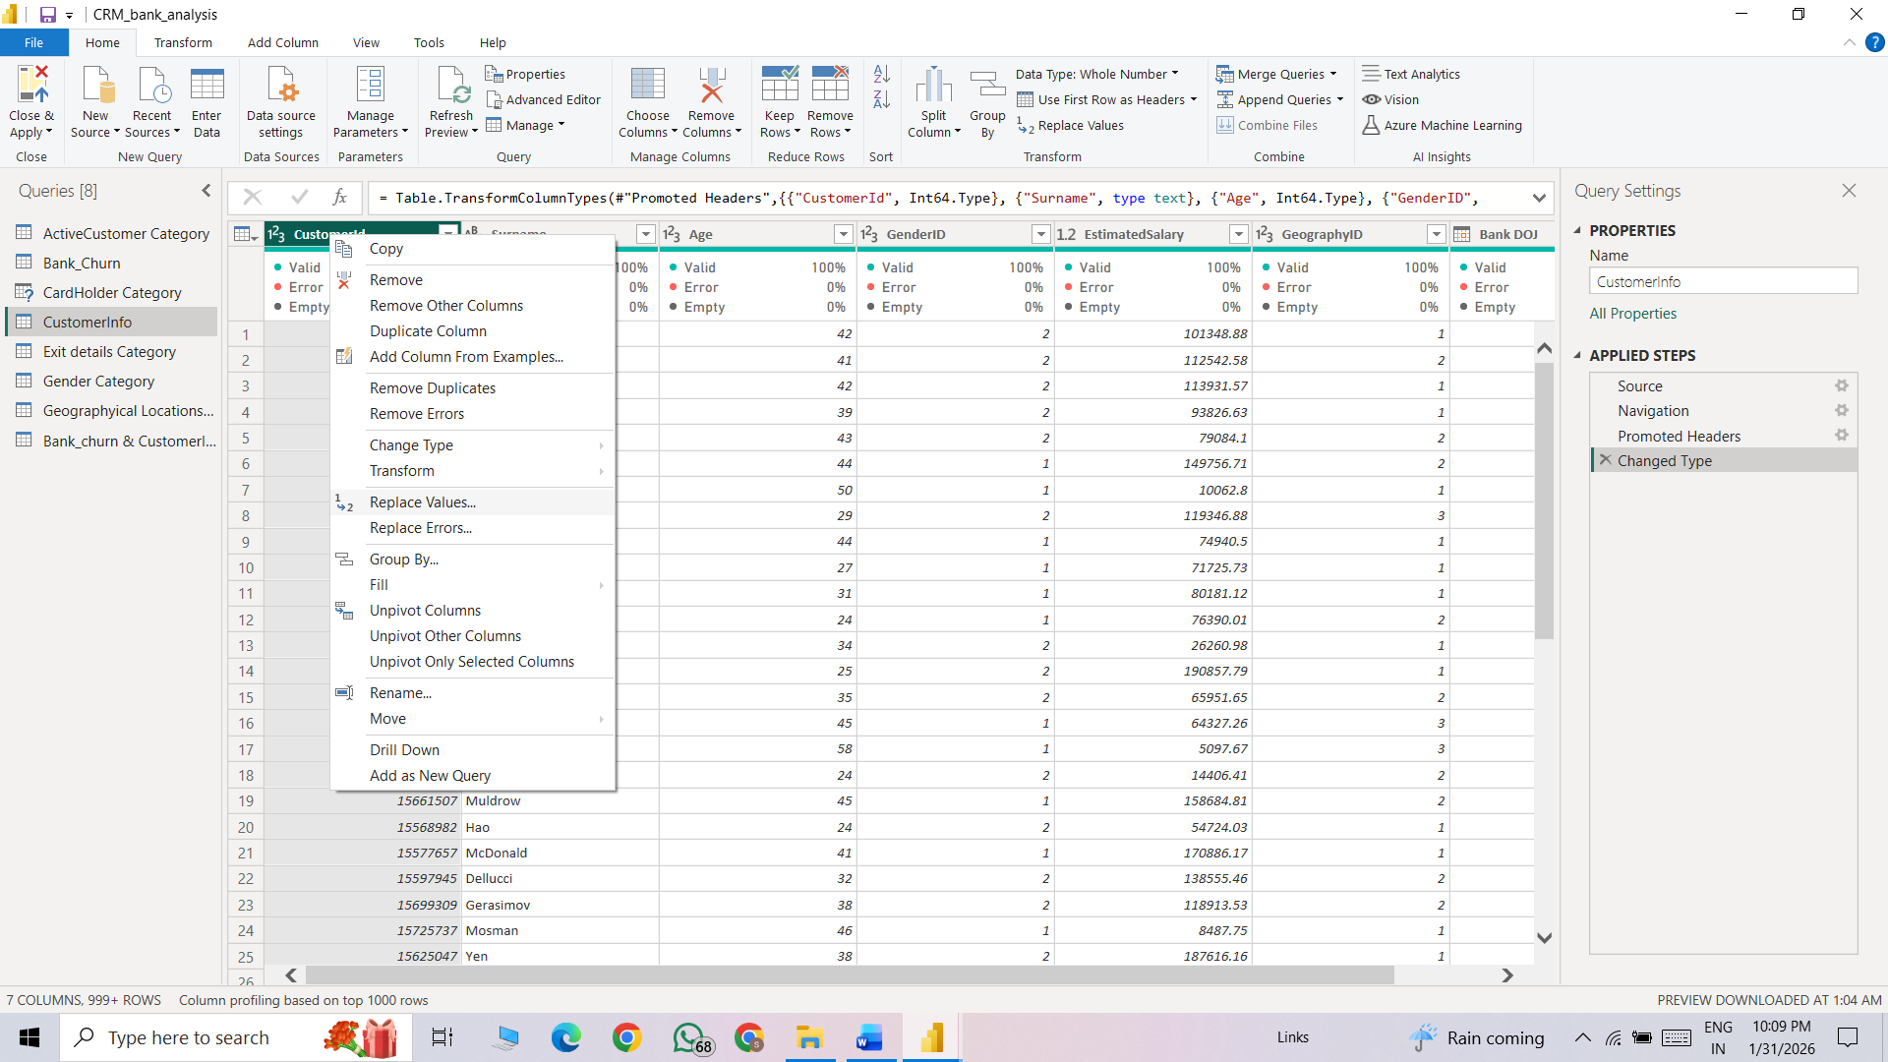

Approach:
- Objective: Were there any missing values in the data, using which tool did you replace them and what are the ways to handle them?
- Method:
  - In the Power Query Editor, the Remove Rows option can be used to eliminate blank records by selecting Remove Blank Rows.
  - Alternatively, by right-clicking on a column and selecting Replace Values, missing entries can be replaced with meaningful placeholders such as Not Available (N/A) or Unknown to ensure better interpretation and insights from the dataset
Q25. Write the query to get the customer IDs, their last name, and whether they are active or not for the customers whose surname ends with “on”.
For obtain Filter columns based on surname column in we apply New Calculated column using Dax Query = EndsWithOn = IF (right ('Bank_churn & CustomerInfo'[CustomerInfo.Surname],2) ="on","Yes","No")
Then we use this column to filter the rows in following columns (CustomerID , Surname, IsActiveMember).
Here total 704 customers having on at end of the surname after apply filter condition.
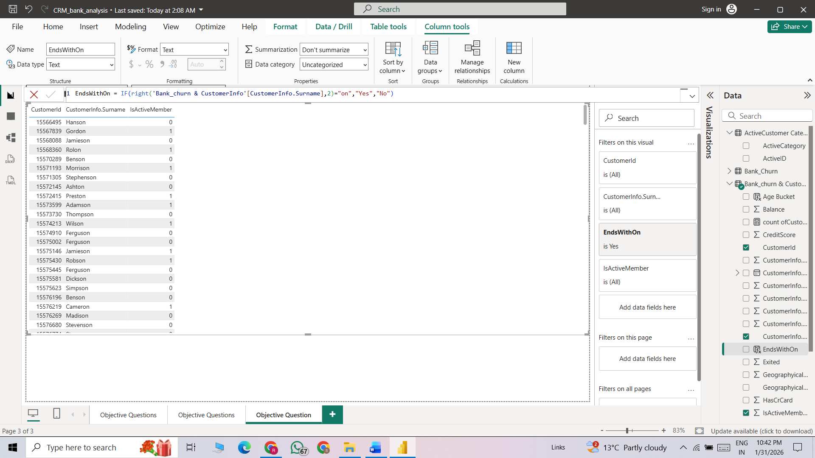
Approach:
- Objective: Write the query to get the customer IDs, their last name, and whether they are active or not for the customers whose surname ends with “on”.
- Method: To complete this task, we used an IF condition in DAX to check whether the customer’s surname ends with “on”. The formula
IF ( RIGHT ( 'Bank_churn & CustomerInfo'[CustomerInfo.Surname], 2 ) = "on", "Yes", "No" )
creates a new column that returns “Yes” if the last two characters of the surname are “on”, otherwise “No”. After creating this column, we applied a filter on “Yes” to get only those customers whose surname ends with “on
Q26. Can you observe any data disrupency in the Customer’s data? As a hint it’s present in the IsActiveMember and Exited columns. One more point to consider is that the data in the Exited Column is absolutely correct and accurate.
Yes, there is a data discrepancy in the customer data. The inconsistency is between the IsActiveMember and Exited columns.
- The Exited column is correct and indicates whether a customer has left the bank.
- However, some customers have Exited = 1 (they have left the bank) but IsActiveMember = 1, which incorrectly marks them as active.

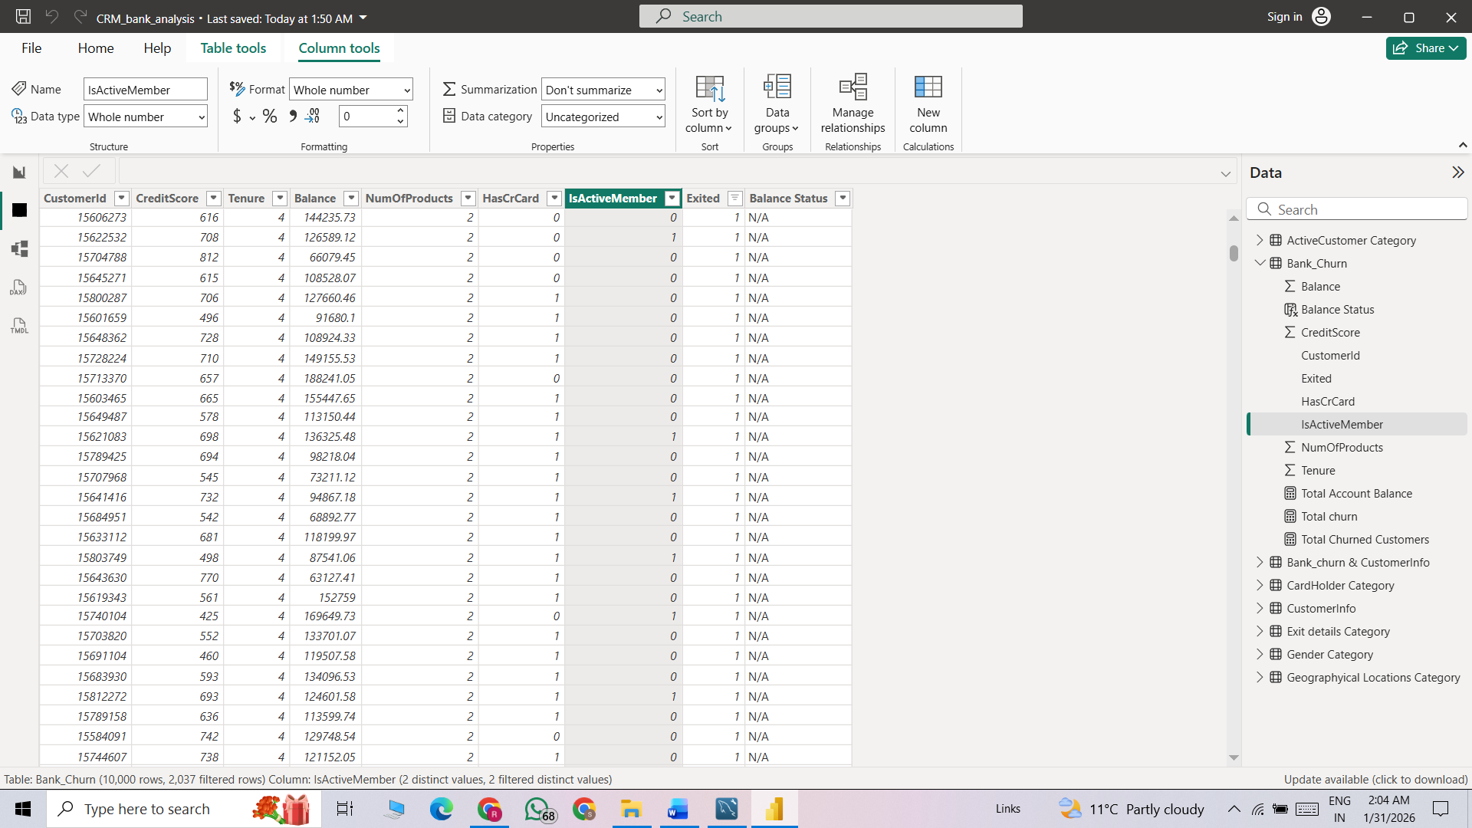

Approach:
- Objective: Can you observe any data disrupency in the Customer’s data? As a hint it’s present in the IsActiveMember and Exited columns. One more point to consider is that the data in the Exited Column is absolutely correct and accurate.
- Method: To check data accuracy, we applied filters to verify that whenever Exited = 1, the corresponding IsActiveMember value should be 0 (since a customer who has exited should not be active). If we find any records where Exited = 1 and IsActiveMember = 1, it indicates a data inconsistency in the dataset.

Subjective Question:
Q1. Customer Behavior Analysis: What patterns can be observed in the spending habits of long-term customers compared to new customers, and what might these patterns suggest about customer loyalty?
Visualization:
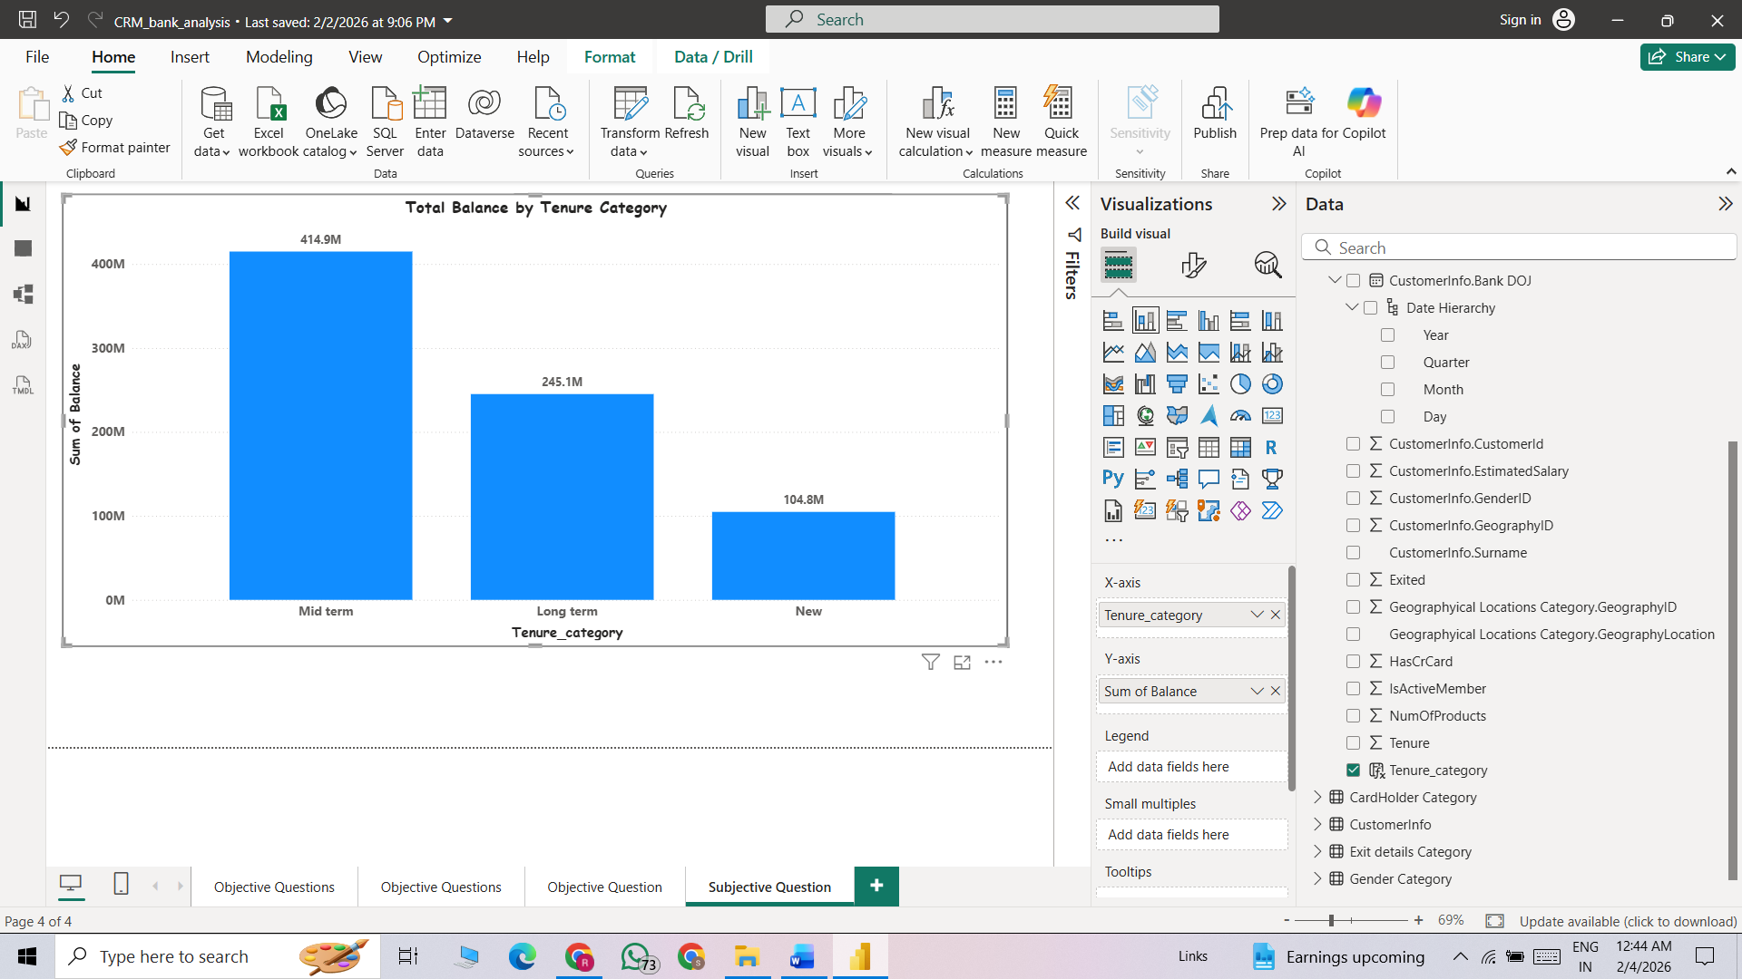
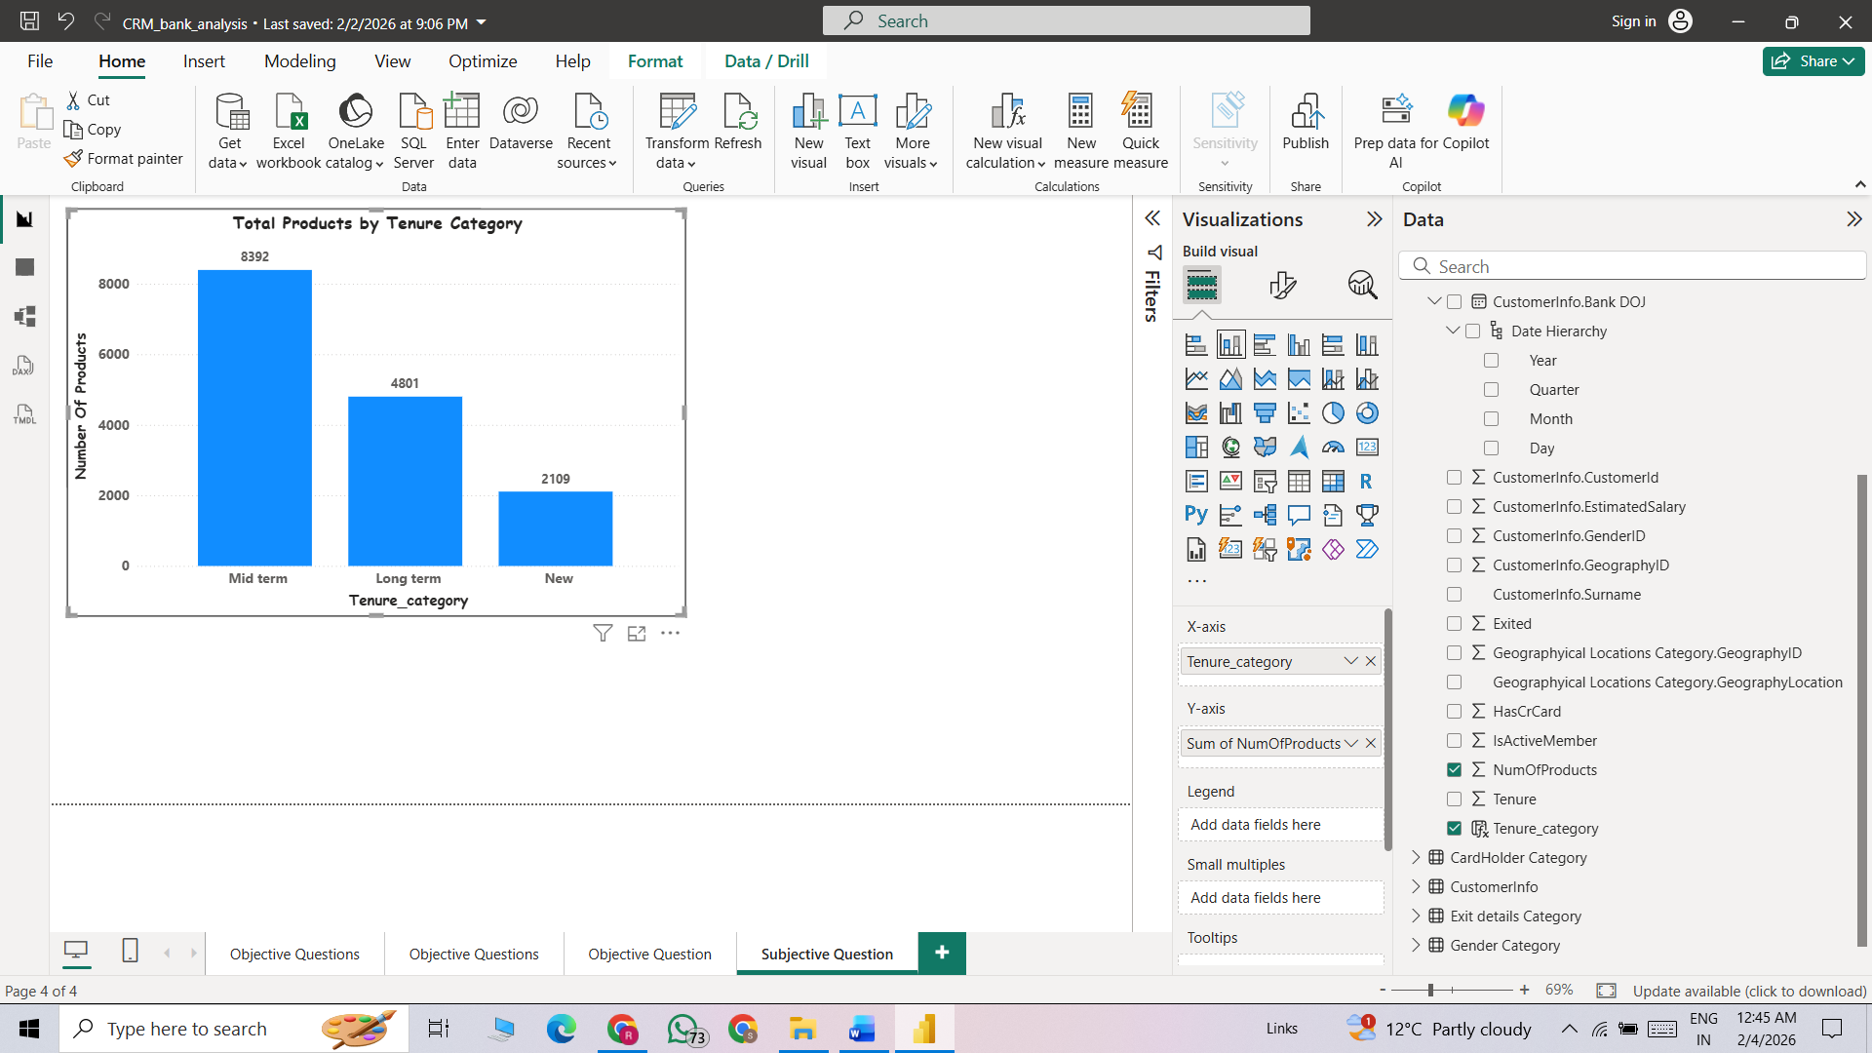
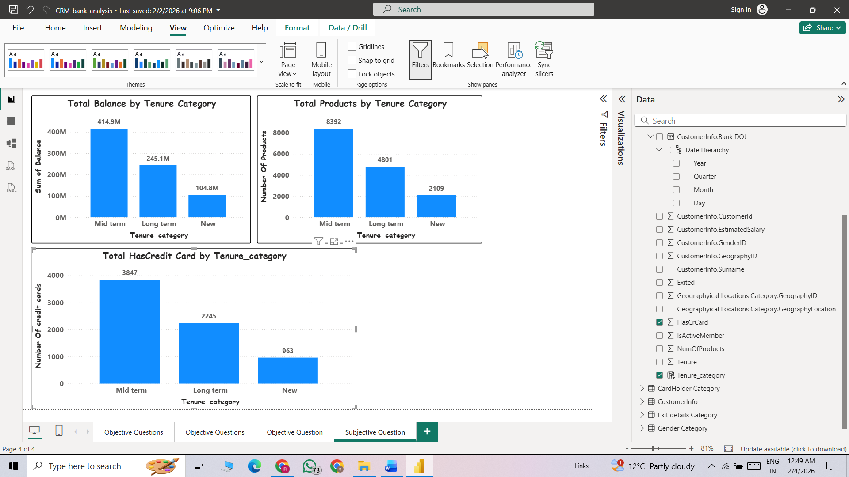
Approach:
Objective:
- Customer Behavior Analysis: What patterns can be observed in the spending habits of long-term customers compared to new customers, and what might these patterns suggest about customer loyalty?

- Method: To solve this question, we analyzed customer spending habits by comparing key columns. First, we compared Total Balance with Tenure to identify whether long-tenure or short-tenure customers maintain higher balances and if any clear pattern exists. Next, we compared Total Products with Tenure Category to see which tenure group uses the most banking products. Finally, we analyzed HasCrCard with Tenure Category to understand how credit card usage varies across different tenure groups.
These three comparisons together help us understand spending behavior, product engagement, and overall customer value in the bank.

- Insights:
  - Mid-term customers contribute the highest total balance (414.9M), total products (8,392), and credit cards (3,847).
This is the most valuable and engaged segment.
Cross-selling appears strongest in this group.
  - Long-term customers contribute significantly but less than mid-term customers (245.1M balance, 4,801 products, 2,245 credit cards).
  - New customers have the lowest totals (104.8M balance, 2,109 products, 963 credit cards).
Lower values are expected due to shorter relationship duration.
Strong opportunity exists for early cross-sell and onboarding strategies.
The ranking is consistent across all metrics:
Mid-term > Long-term > New.

- Recommendation:
  - Strengthen onboarding programs to increase product and credit card adoption among new customers.
  - Protect mid-term customers with loyalty rewards and personalized offers, as they generate the highest value.
Q2. Product Affinity Study: Which bank products or services are most commonly used together, and how might this influence cross-selling strategies?
Group | Description
Group A | HasCrCard = 1 and NumOfProducts = 1
Group B | HasCrCard = 1 and NumOfProducts > 1
Group C | HasCrCard = 0 and NumOfProducts > 1
Group D | HasCrCard = 0 and NumOfProducts = 1
Visualization:
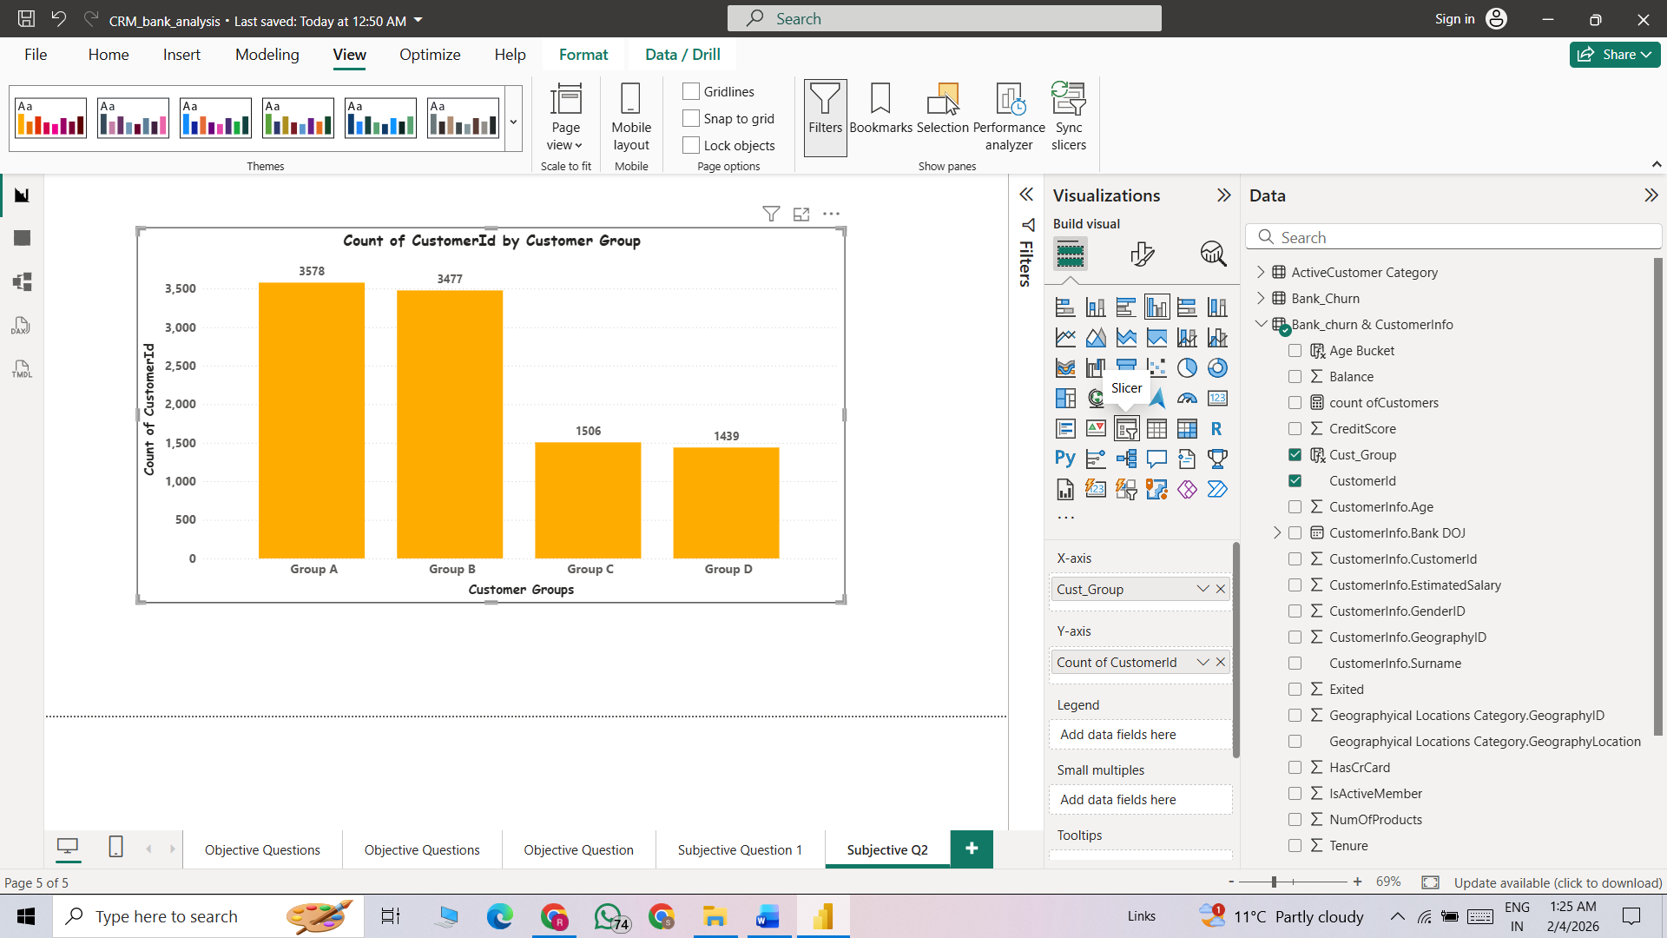
Approach:
- Objective: Product Affinity Study: Which bank products or services are most commonly used together, and how might this influence cross-selling strategies?
- Method: To solve this question and know the product affinity we create 4 groups (A, B, C, D) help of Dax Query and identify how many customers lies in these category
  - Group conditions are following them
- Group A | HasCrCard = 1 and NumOfProducts = 1
- Group B | HasCrCard = 1 and NumOfProducts > 1
- Group C | HasCrCard = 0 and NumOfProducts > 1
- Group D | HasCrCard = 0 and NumOfProducts = 1

- Insights:
  - Majority of customers (70.5%) have a credit card.
  - Multi-product ownership is almost evenly split between credit card holders and non-holders.
  - Group A (Card + Single Product) is the largest segment and represents the biggest cross-sell opportunity.
  - Group B (Card + Multiple Products) is the most valuable and loyal customer segment focus on retention.
  - Group C (No Card + Multiple Products) shows strong product affinity and is ideal for credit card cross-selling.
  - Group D (No Card + Single Product) is the least engaged segment and may have higher churn risk.
- Recommendation:
  - Focus on Cross-Selling (High Impact Opportunity) Target Group A (Card + Single Product) with bundled product offers.
  - Retain High-Value Customers
Prioritize Group B (Card + Multiple Products) for retention programs.
  - Promote Credit Cards to the Right Audience
Target Group C (No Card + Multiple Products) with pre-approved credit card offers.
- Improve Engagement for Low-Activity Customers for Group D (No Card + Single Product)
Q3. Geographic Market Trends: How do economic indicators in different geographic regions correlate with the number of active accounts and customer churn rates?
Visualization:

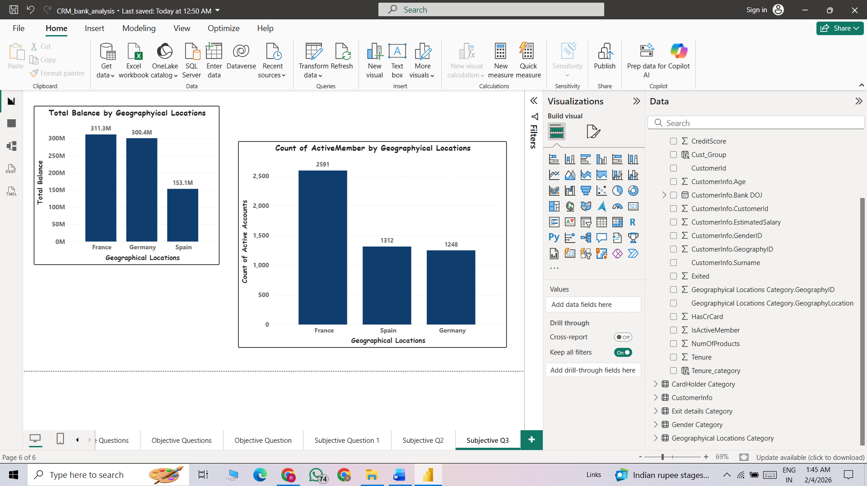

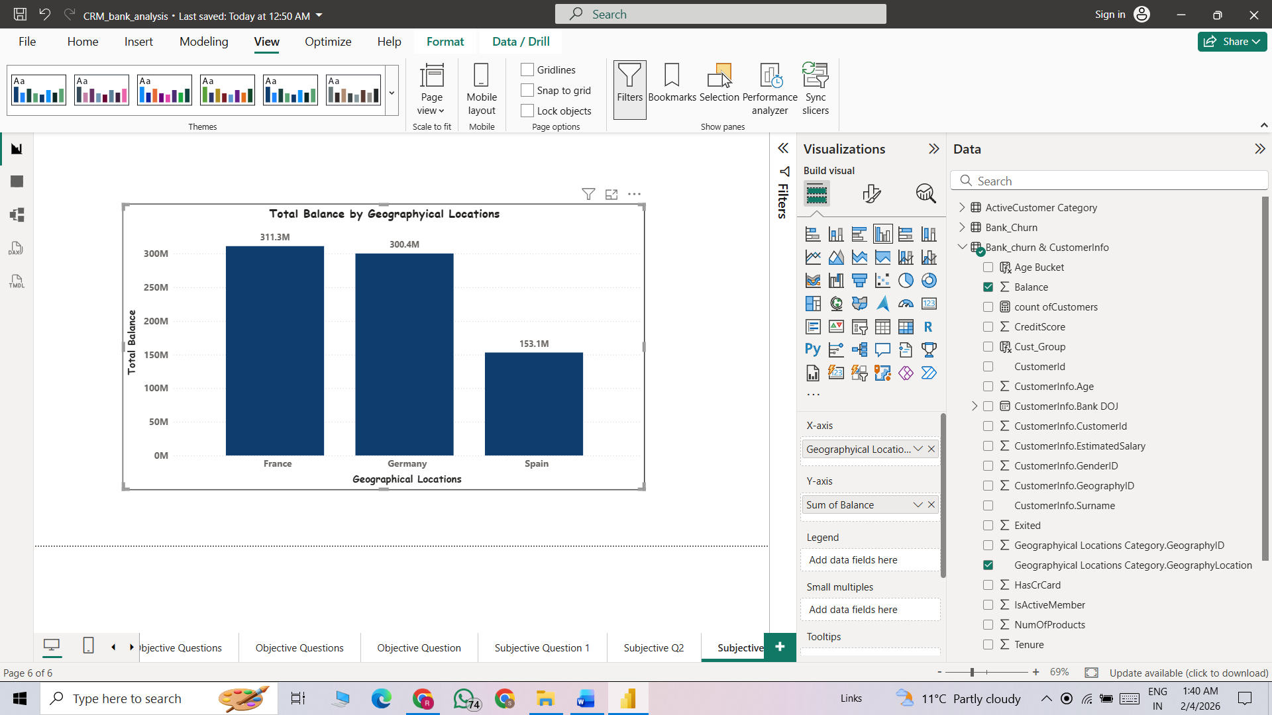
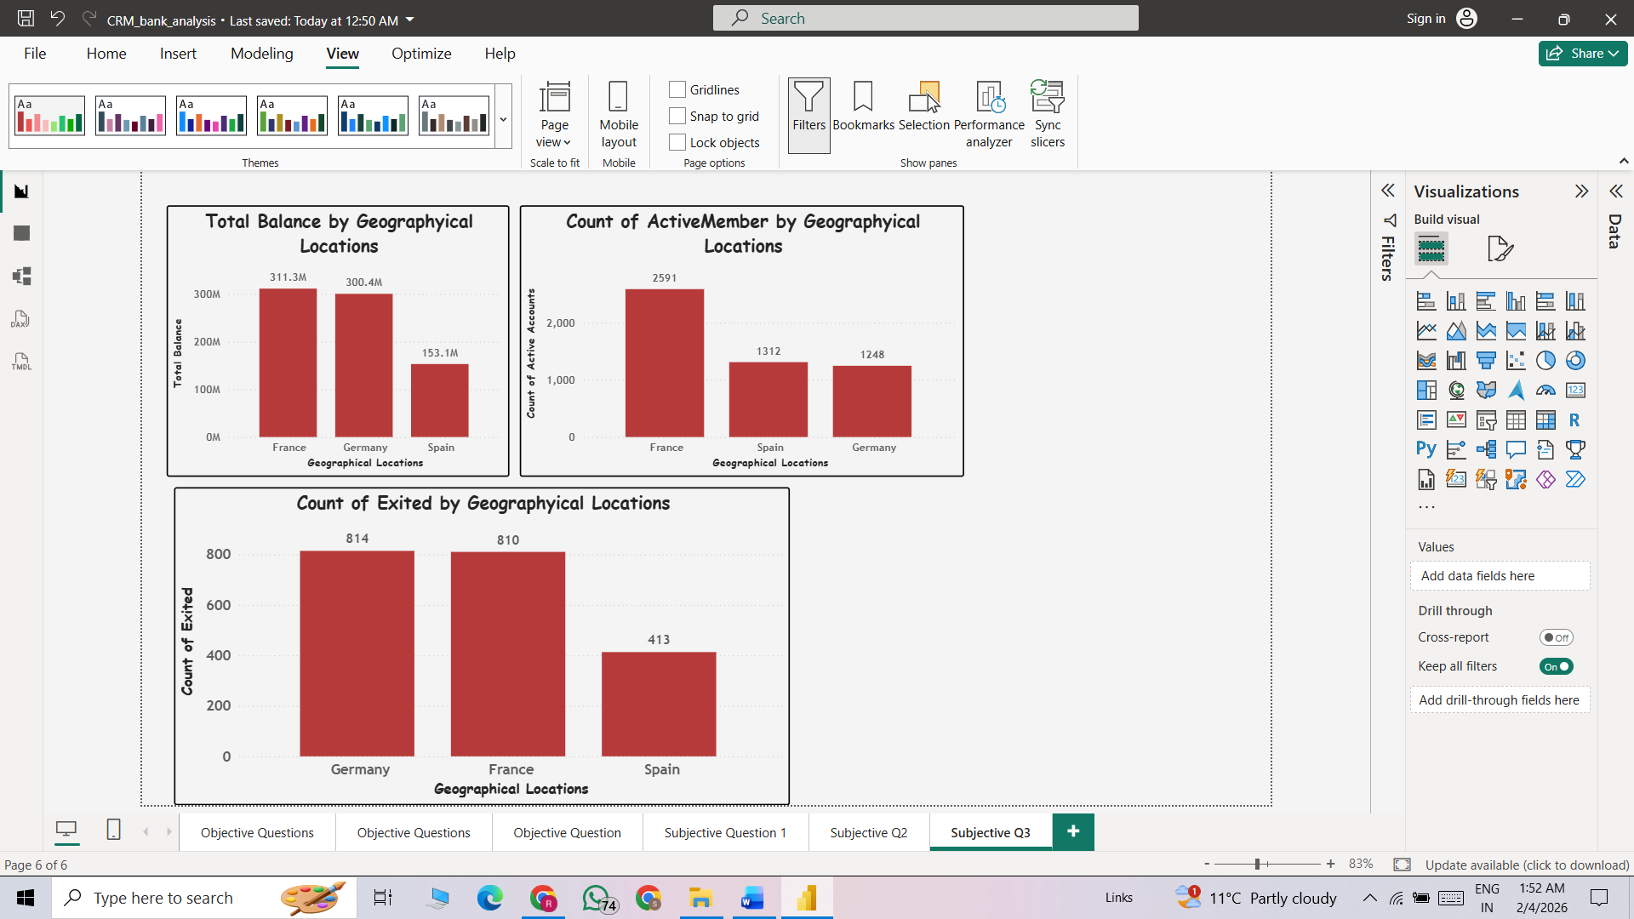
Approach:
Objective:
- Geographic Market Trends: How do economic indicators in different geographic regions correlate with the number of active accounts and customer churn rates?
- Method:
For solve this Question and identify economic indicators by regions we use some key columns first visuals shows the Active Member count by Geography locations. Second visuals show the total balance by geographical locations and last one shows the Exited count by geographical locations.
- Insights:
- France have Highest active members 2591 then Spain 1312 at the least Germany 1248
- France has highest total balance 311.03 M then Germany 300M at the least Spain 153.14M
- Germany has highest customer churn 814 then France 810 and the end Spain have 413.

- Recommendation:
  - Germany has high total balance but the highest churn, making it a high-risk region. The priority should be reducing churn through targeted retention strategies and improving customer experience.
  - Spain is more stable with lower churn but has the lowest total balance. The strategy here should focus on growth, cross-selling, and increasing average customer value.

Q4. Risk Management Assessment: Based on customer profiles, which demographic segments appear to pose the highest financial risk to the bank, and why?
Visualization:

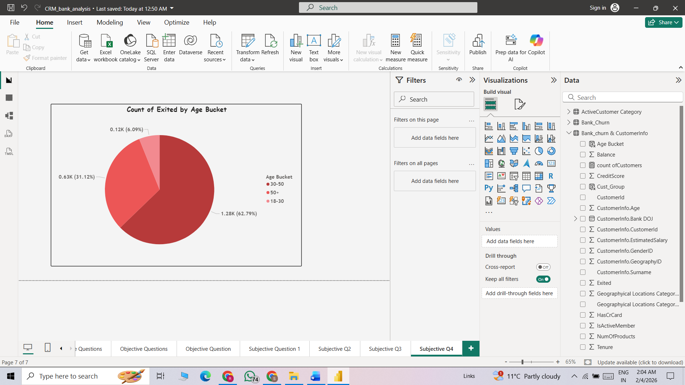
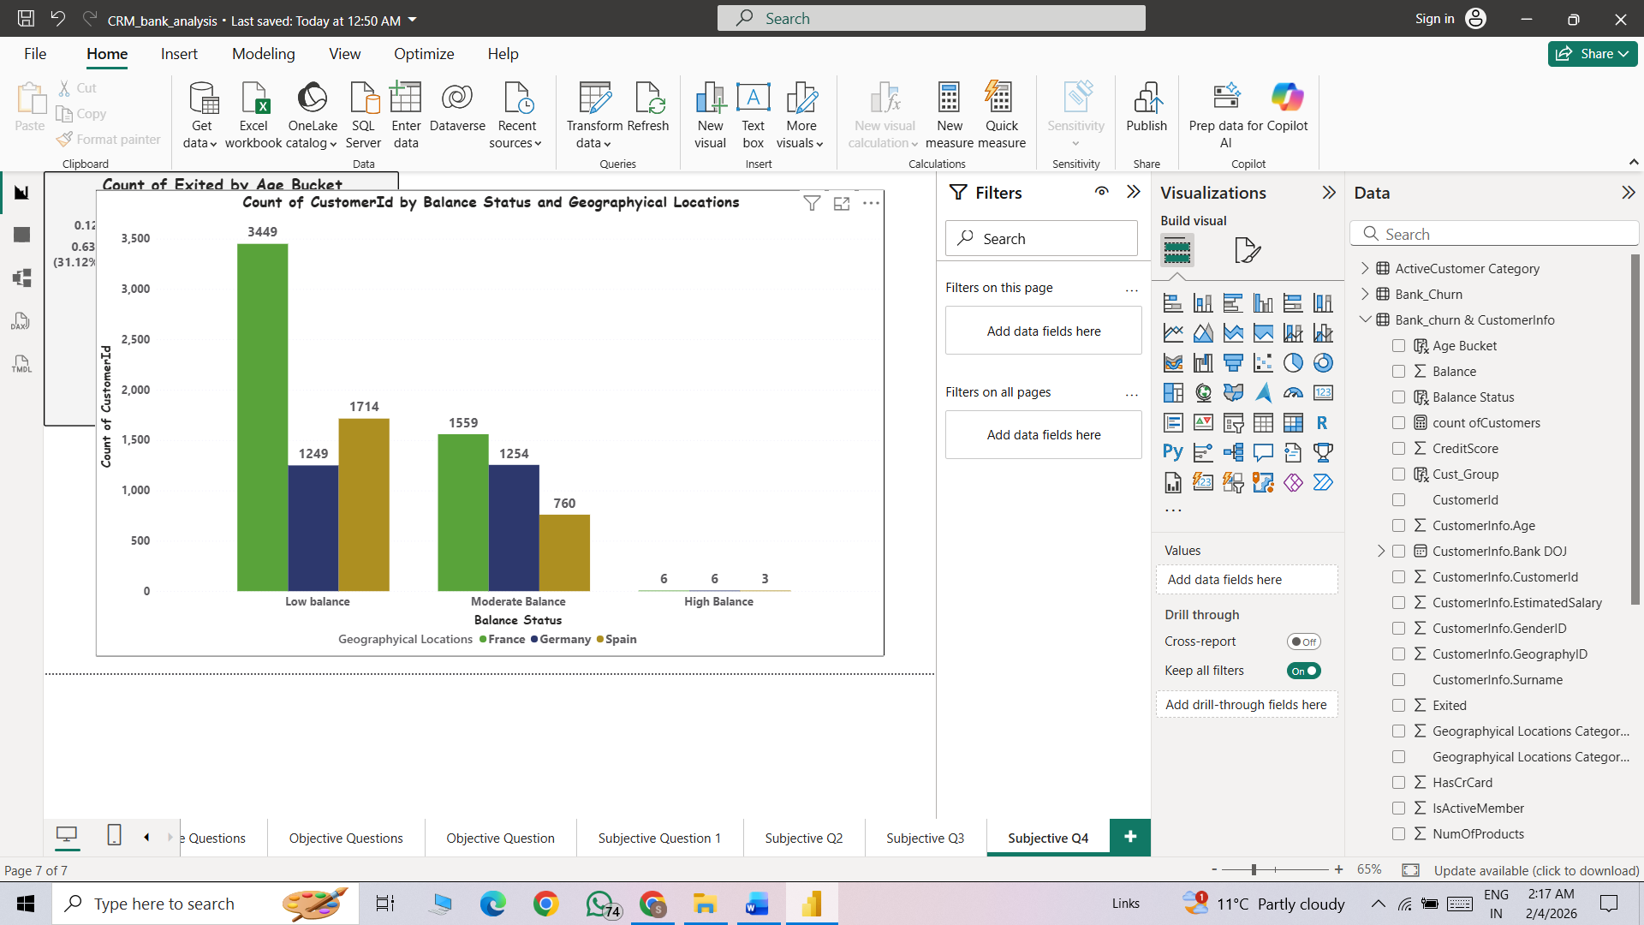

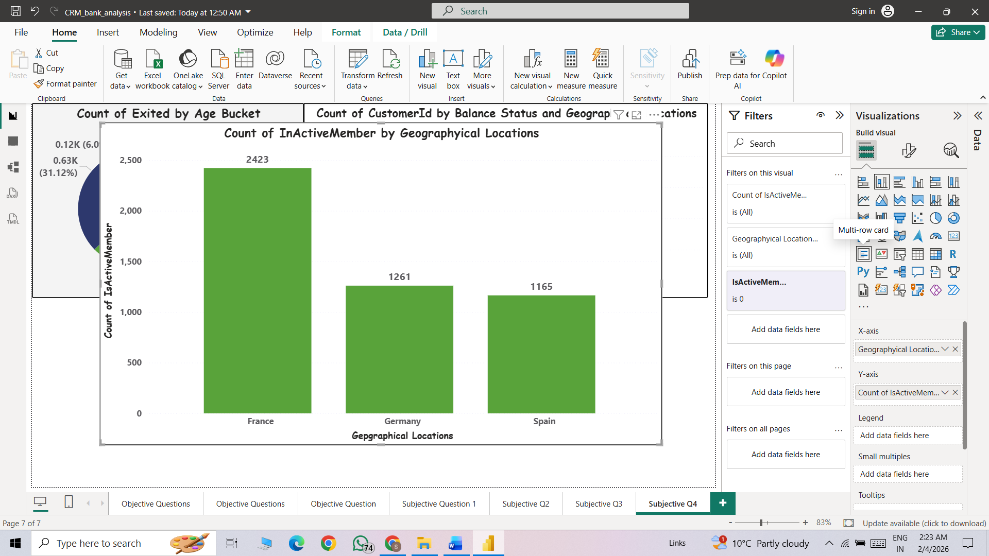
Approach:
- Objective: Risk Management Assessment: Based on customer profiles, which demographic segments appear to pose the highest financial risk to the bank, and why?
- Method: In the Question Risk assessment can be done following ways:
  - Exited Proportion by Age bucket
  - Customer Count by Balance status and Geographical Locations.
  - Count Inactive members by geographical locations
The risk assessment is conducted by analyzing customer behavior across age, account balance, and geographical location.
- Insights:
France has the highest number of inactive members, with 2,423 inactive customers. This is almost double the count in Germany (1,261) and Spain (1,165).
Germany and Spain have similar, but significantly lower inactive counts, indicating comparatively better customer activity or engagement.
France (3449) has the highest number of low-balance customers.
Spain (1714) is second.
Germany (1249) has the lowest among the three
- Recommendation:
  - Since France has:
Highest inactive customers (2,423)
Highest low-balance customers (3,449)
Offer limited-time incentives for inactive users (zero-fee transactions, bonus interest).
Introduce loyalty programs for low-balance customers to increase deposits.

Q5. Customer Tenure Value Forecast: How would you use the available data to model and predict the lifetime (tenure) value in the bank of different customer segments?
Visualization:
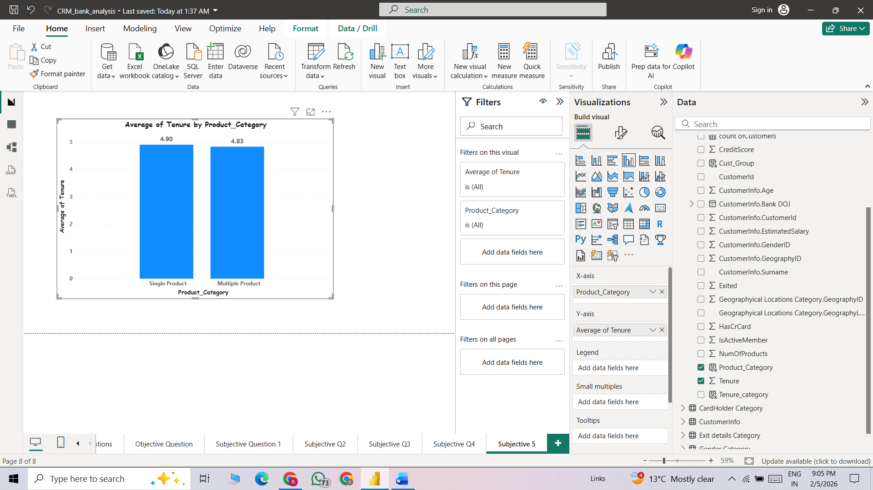
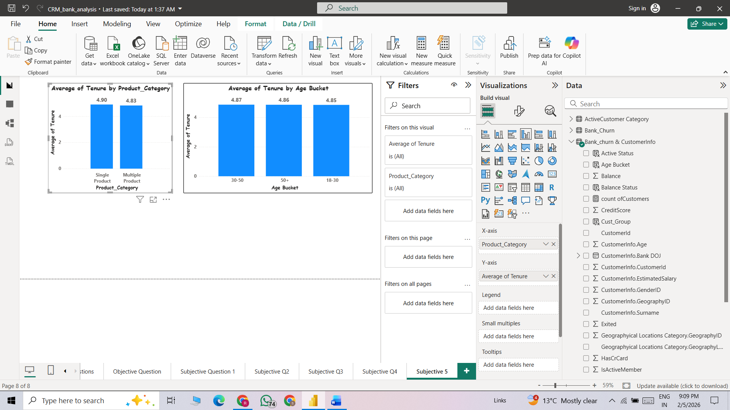
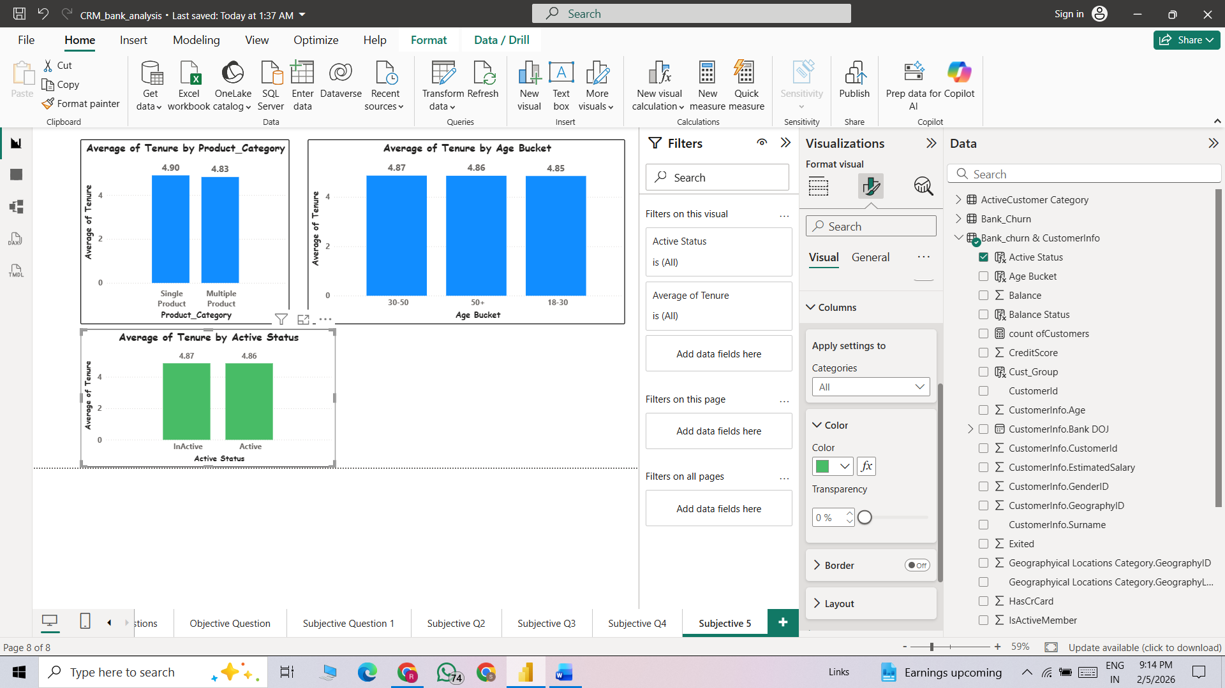
Approach:
- Objective:
  - Customer Tenure Value Forecast: How would you use the available data to model and predict the lifetime (tenure) value in the bank of different customer segments?
- Method: To Predict the Customer Tenure value, we do some key columns comparisons are following their:
  - Average Tenure by Product Category (Single Product, Multiple Products)
  - Average Tenure by Age bucket’s
  - Average Tenure by Active Status
By these comparisons, we can get insights into whether the average tenure is higher for single-product users or multiple-product users. We can also determine which age bucket has the highest average tenure and what the average tenure is for active and inactive users.
- Insights:
  - 1. Average Tenure by Active Status
    - Inactive customers: 4.87 years
    - Active customers: 4.86 years
  - The average tenure is almost the same for both active and inactive customers.
This indicates that tenure is not a strong factor in determining whether a customer is active or inactive.
  - 2.Average Tenure by Age Bucket
    - 30-50 years: 4.87 years (Highest)
    - 50+ years: 4.86 years
    - 18–30 years: 4.85 years
  - The 30-50 age group has the highest average tenure, but the difference across age groups is very small.
This shows that tenure is fairly consistent across all age categories.
- 3.Average Tenure by Product Category
- Single product users: 4.90 years
- Multiple product users: 4.83 years
- Recommendation:
  - Tenure alone should not be used to predict churn, as it is similar across active and inactive customers. Combine it with other factors like balance and product usage.
  - Target long-tenure single-product customers for cross-selling opportunities.

Q6. Marketing Campaign Effectiveness: How could you assess the impact of marketing campaigns on customer retention and acquisition within the dataset? What extra information would you need to solve this?
As per given dataset we don’t have marketing campaign data so it’s not possible to compare directly to calculate impact of marketing campaigns on customer retention.
To properly assess marketing campaign effectiveness, we need at least one additional table
Marketing_Campaigns table
Campaign_ID
Campaign_Name
Start_Date
End_Date
Channel
Cost
With the current dataset, we can analyse customer churn and onboarding trends but cannot directly measure marketing campaign effectiveness because there is no campaign exposure data. To evaluate the impact of marketing on customer retention and acquisition, we would need campaign-level information. Without this, any conclusions would be correlational, not causal.
Visualization:
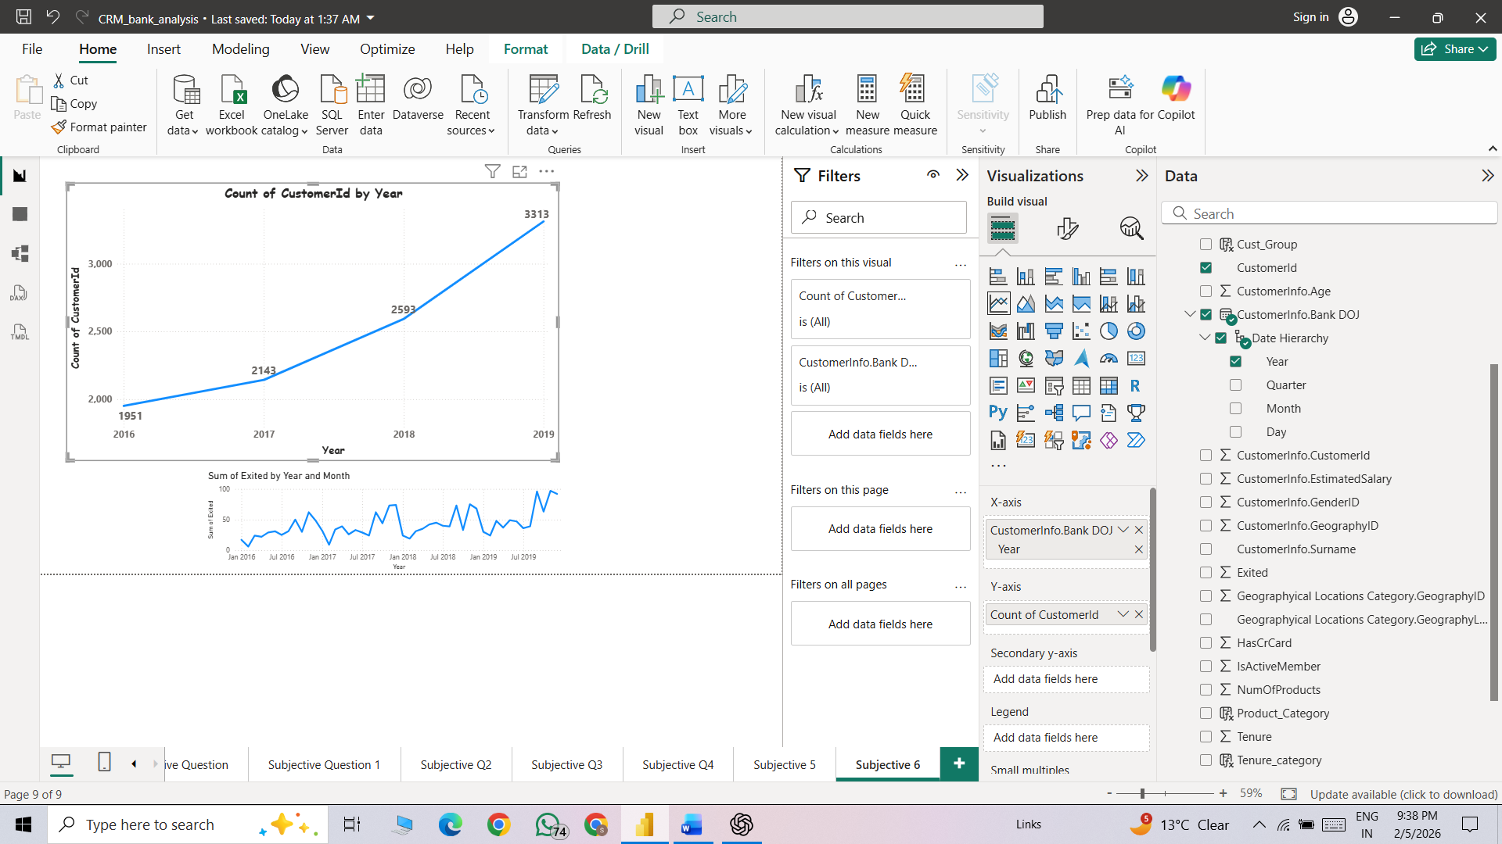
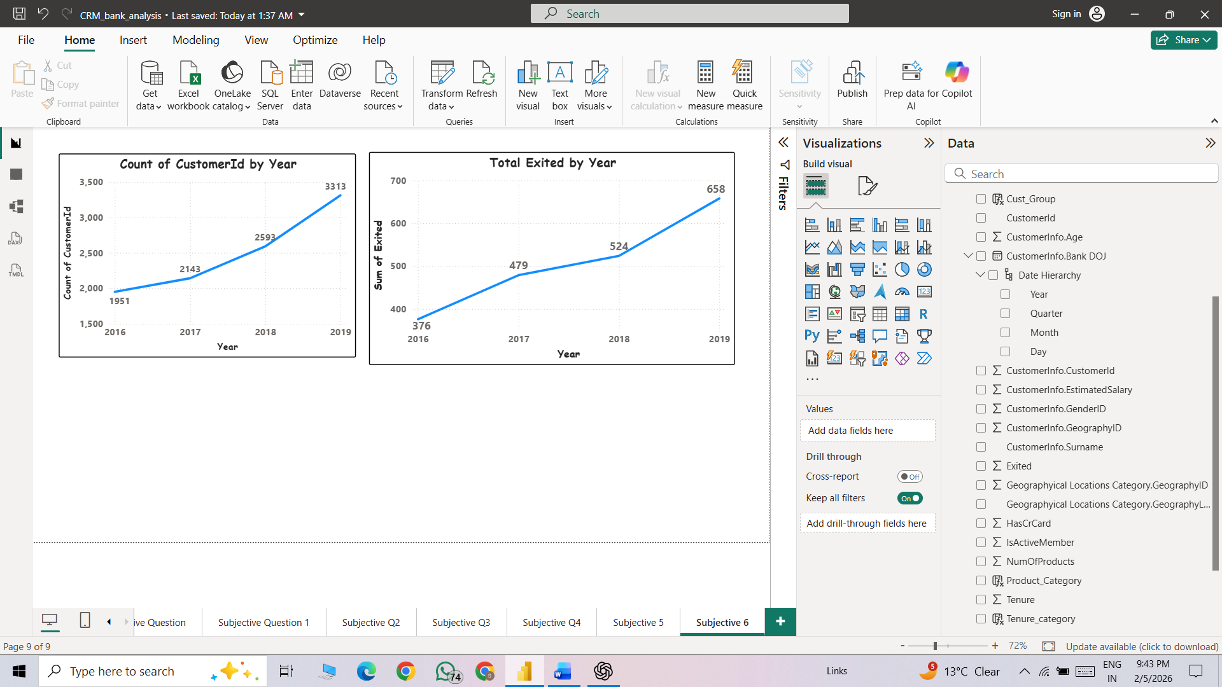
Approach:
- Objective:
  - Marketing Campaign Effectiveness: How could you assess the impact of marketing campaigns on customer retention and acquisition within the dataset? What extra information would you need to solve this?
- Method:
  - As per given dataset we don’t have marketing campaign data so it’s not possible to compare directly to calculate impact of marketing campaigns on customer retention.
  - With the current dataset, we can analyse customer churn and onboarding trends but cannot directly measure marketing campaign effectiveness because there is no campaign exposure data.
- Insights:
  - Total Customers Exited by Year
    - 2016: 376
    - 2017: 479
    - 2018: 524
    - 2019: 658
  - Customer exits are increasing every year. The highest jump is seen from 2018 to 2019. This shows a rising churn trend, which is a concern for the bank.
  - Total Customers by Year
- 2016: 1951
- 2017: 2143
- 2018: 2593
- 2019: 3313
The total number of customers is also increasing steadily every year. The biggest growth is in 2019.
- Recommendation:
  - Strengthen customer retention strategies since churn is increasing every year.
  - Analyze the main reasons for high churn in 2019 and take corrective action.
  - Implement an early warning system to identify and retain at-risk customers.
Q7. Customer Exit Reasons Exploration: Can you identify common characteristics or trends among customers who have exited that could explain their reasons for leaving?
Visualization:

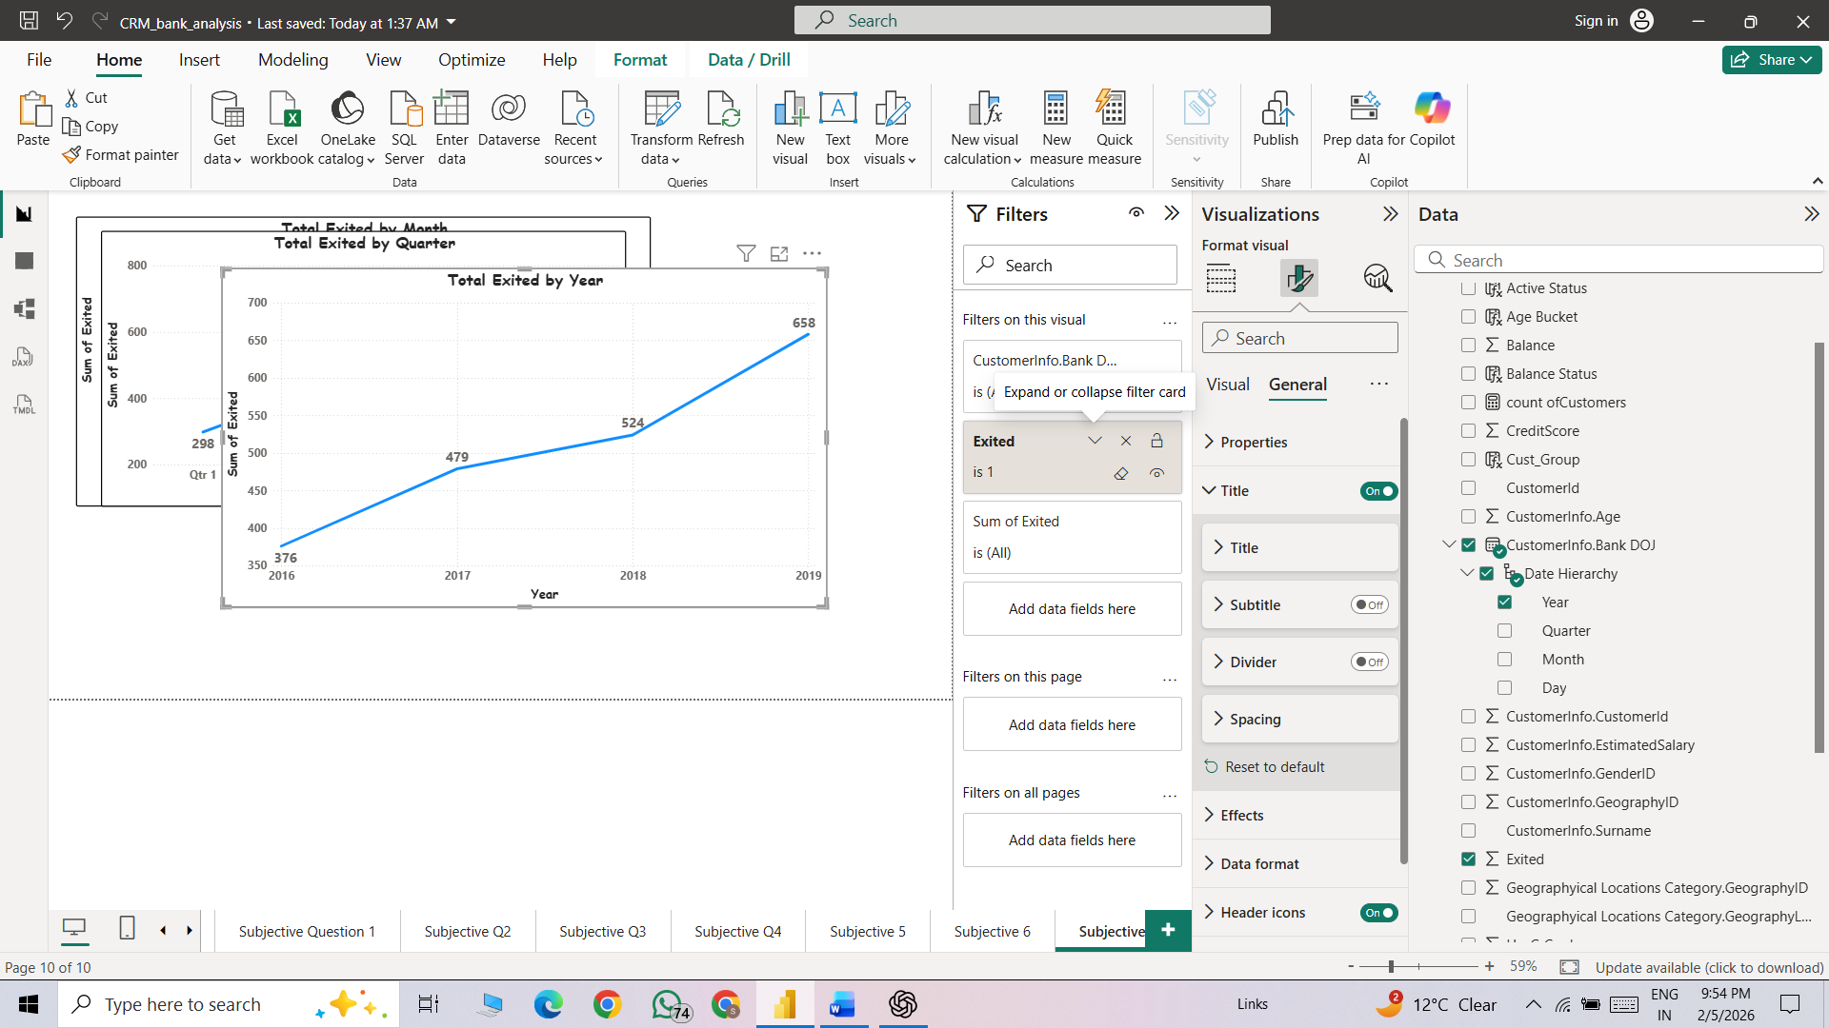
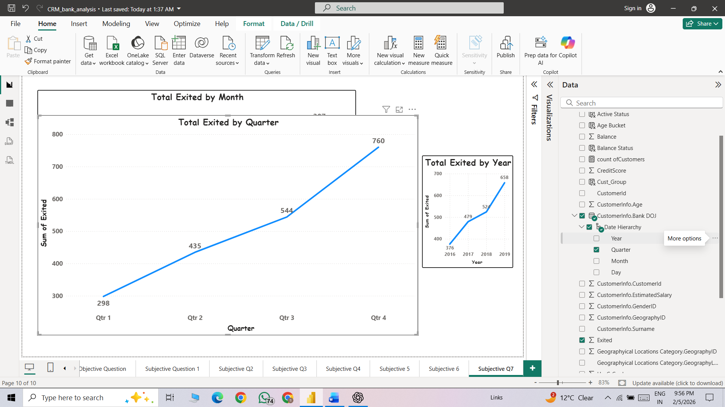
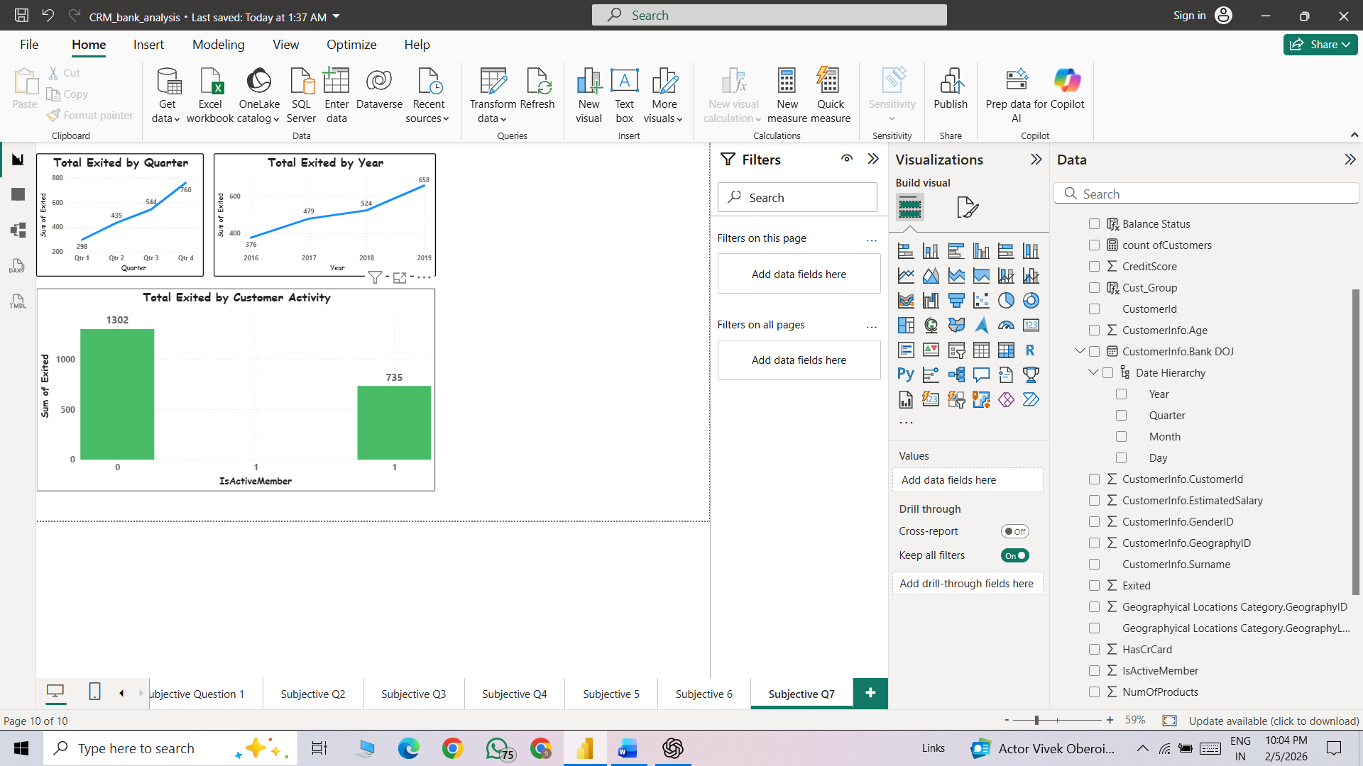
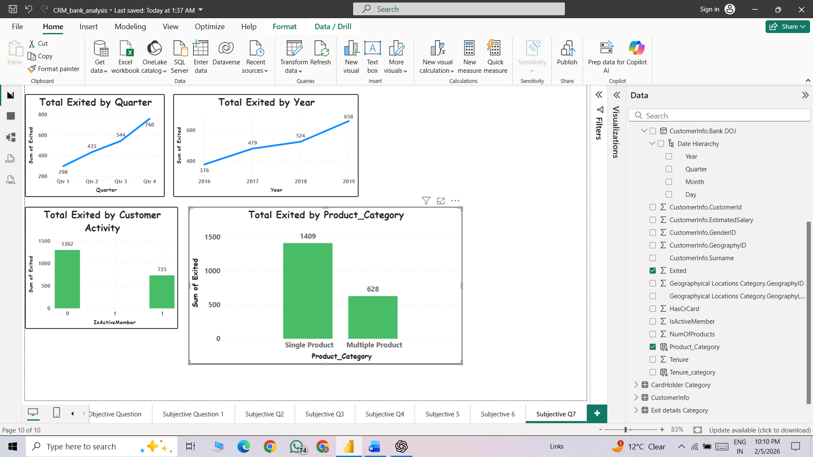
Approach:
- Objective:
  - Customer Exit Reasons Exploration: Can you identify common characteristics or trends among customers who have exited that could explain their reasons for leaving?
- Method:
  - To Solve this Question, we use some key columns comparison to achieve this task are following them:
    - Total Exited Customers trend by Years
    - Total Exited Customers trend by Quatres
    - Total Exited Customer by Active Status
    - Total Exited Customer by Product Category
  - Through these comparisons, we can understand the exit trends and identify possible reasons why customers are leaving the bank.
- Insights:
  - 1. Total Exited by Year
    - Customer exits are increasing every year (376 in 2016 to 658 in 2019).
    - The biggest increase is from 2018 to 2019.
    - This shows a rising churn trend, which is a serious concern.
  - 2.Total Exited by Quarter
- Q1: 298
- Q2: 435
- Q3: 544
- Q4: 760
- Churn increases steadily across quarters, with the highest exits in Q4.
This suggests a possible seasonal effect or year-end dissatisfaction.

- 3.Total Exited by Customer Activity
    - Inactive customers: 1302
    - Active customers: 735
  - Inactive customers are leaving almost twice as much as active customers.
This indicates low engagement is a major reason for churn.
- 4. Total Exited by Product Category
- Single product: 1409
- Multiple product: 628
Single-product customers are churning much more than multiple-product customers.
Customers with multiple products appear more loyal.
- Recommendation:
  - Re-engage inactive customers through targeted campaigns.
  - Increase cross-selling to reduce churn among single-product customers.
  - Launch retention strategies before Q4 to control year-end churn.
  - Use an early warning system to identify and retain at-risk customers.
Q8. Are 'Tenure', 'NumOfProducts', 'IsActiveMember', and 'EstimatedSalary' important for predicting if a customer will leave the bank?
Yes Tenure, NumOfProducts, IsActiveMember, and EstimatedSalary are important predictors of customer churn, but their impact is not equal. Based on your dataset structure and typical churn behaviours.
1. Tenure – Moderately Important
- Customers with shorter tenure show a higher likelihood of exiting.
- Longer-tenure customers are more stable and loyal.
Why:
Short tenure often indicates weak onboarding or unmet expectations early on.
2. NumOfProducts – Highly Important
- Customers with fewer products (1–2) are more likely to leave.
- Customers using multiple products are less likely to churn.
Why:
More products increase customer dependency and switching costs.
3. IsActiveMember – Very Important (Strongest Predictor)
- Inactive members (IsActiveMember = 0) have a significantly higher exit rate.
- Active customers are far more likely to stay.
Why:
Engagement is a direct indicator of customer satisfaction and relationship strength.
4.EstimatedSalary – Weak to Moderate Importance
- Salary alone does not strongly predict churn.
- High-salary customers may still leave if engagement is low.
Why:
Financial capacity ≠ customer satisfaction.

Q9. Utilize SQL queries to segment customers based on demographics and account details.
SQL Code:
select
g.geographyLocation,
(case when b.balance>150000 then "high balance"
else "Low Balance" end) as Balance_Category,

(Case when b.tenure>5 then "Long Tenure"
when b.tenure<=5 and b.tenure>2 then "Moderate Tenure"
else "New"
end) as Tenure_category, count(c.customerID) as CntOFCustomers
from CustomerInfo c
join geography g
on c.geographyID = g.geographyID
join bank_churn b
on b.customerID = c.customerID
group by g.geographyLocation, Balance_Category, Tenure_category
order by g.geographyLocation
- Output: A single table showing
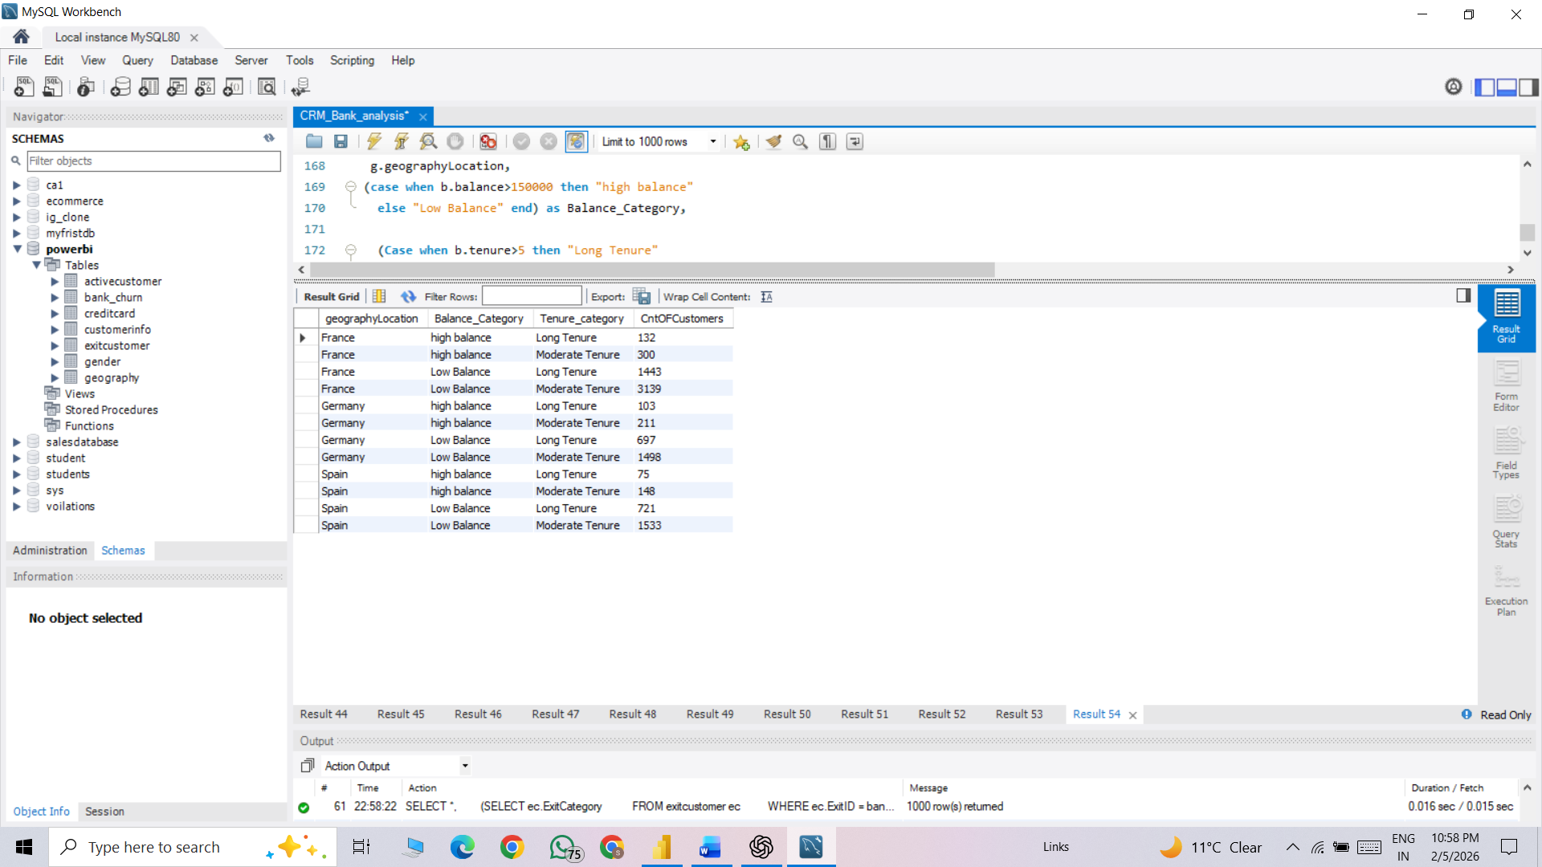
Visualization:

Approach:
- Objective: Utilize SQL queries to segment customers based on demographics and account details.
- Method: To solve this question, we joined three tables: customer_info, Geography_locations, and Bank_churn. Then, we created balance categories as High Balance and Low Balance based on the bank balance. Finally, we calculated the customer count based on balance category and geographical location.
- Insights:
  - Germany is currently our most valuable market, holding over half of our total capital despite having a smaller customer base than France. While France is our clear leader in terms of popularity and customer acquisition, those accounts tend to hold much lower balances on average. Spain remains our smallest market in both categories.
- Recommendation:
- Upsell France: Convert the high customer volume into higher balances through premium incentives.
- Protect Germany: Prioritize retention for this high-value "money pot" to secure 50% of your total capital.
- Test Spain: Run targeted growth pilots to see if it can mirror France’s scale or Germany’s wealth.
- Segment Branding: Use mass-market messaging for France and wealth-management focus for Germany.
Q10. How can we create a conditional formatting setup to visually highlight customers at risk of churn and to evaluate the impact of credit card rewards on customer retention?
We categorized the churn based on following DAX Query
Churn Risk = IF('Bank_churn & CustomerInfo'[Exited]=1,"High Risk",IF(AND('Bank_churn & CustomerInfo'[IsActiveMember]=0,'Bank_churn & CustomerInfo'[Balance]=0),"Medium Risk","Low Risk"))
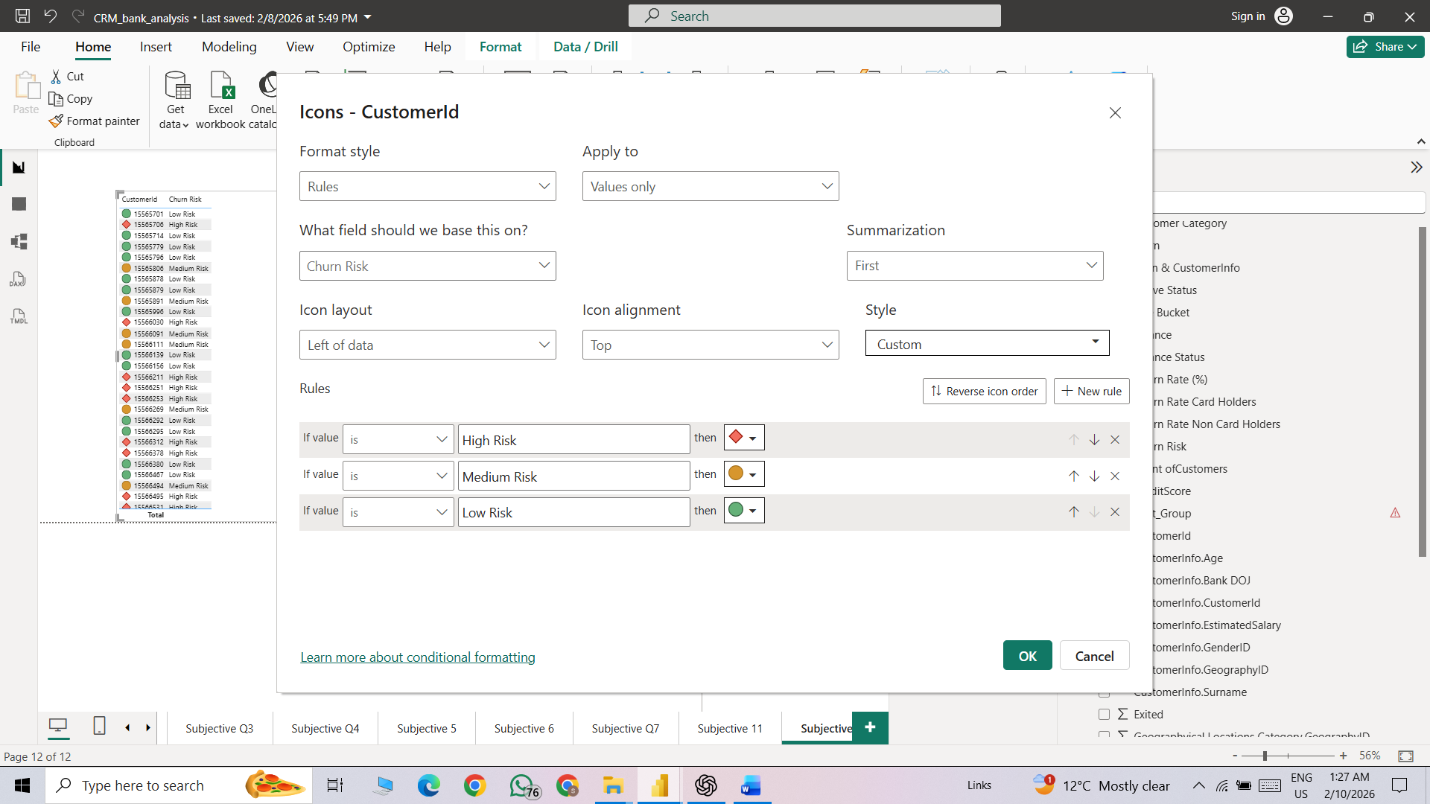
Visualization:
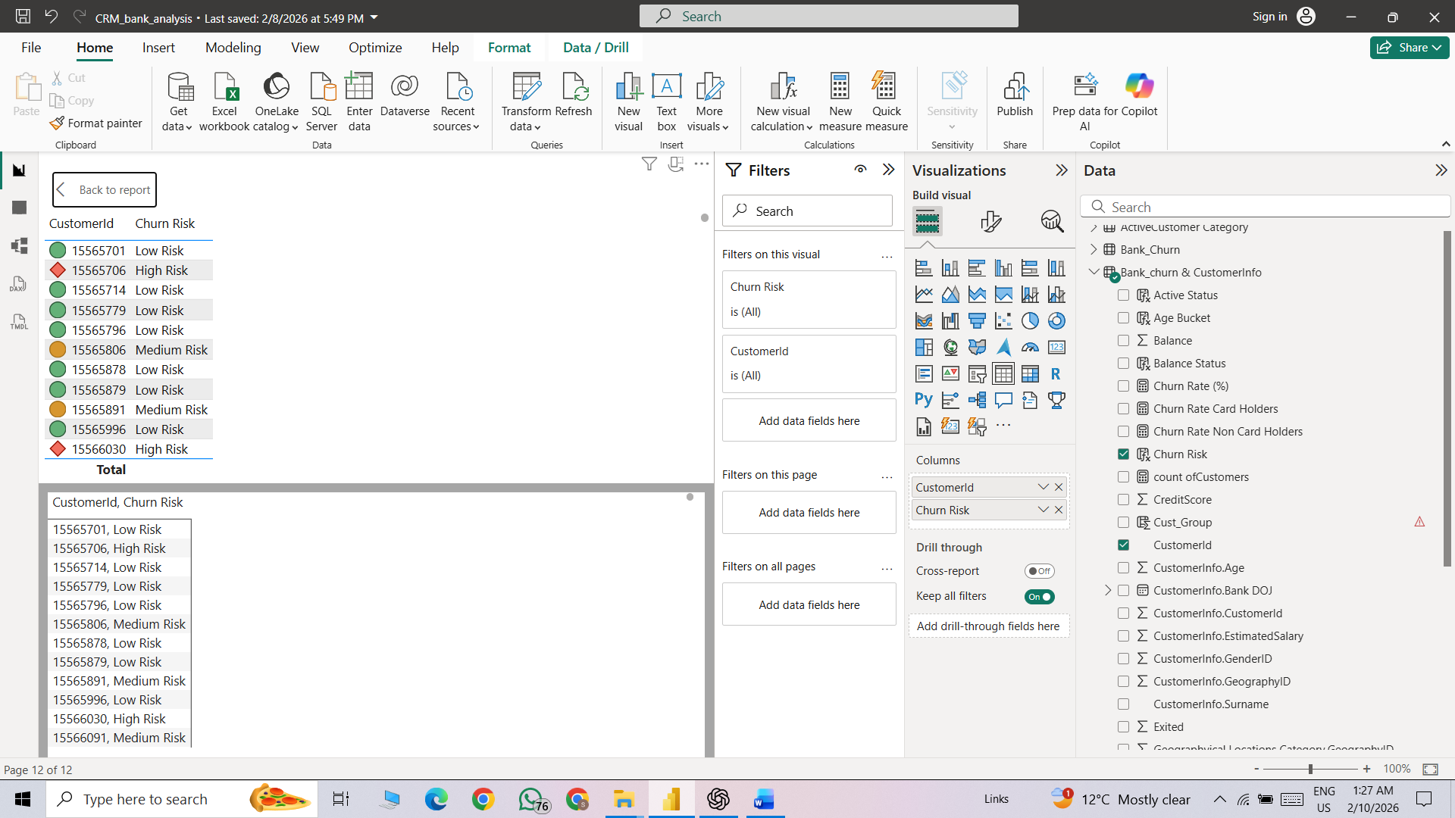
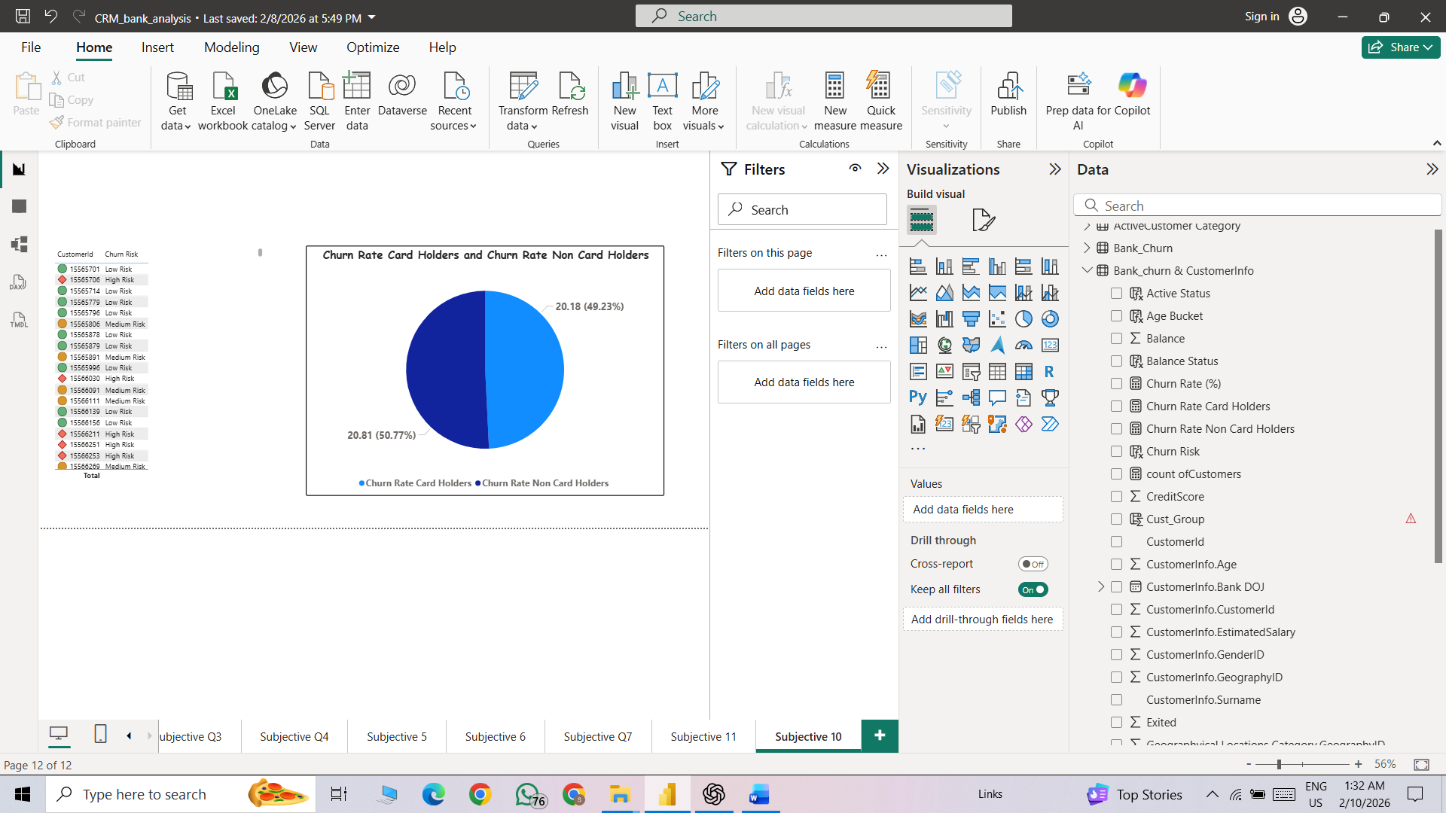
Approach:
- Objective:
  - How can we create a conditional formatting setup to visually highlight customers at risk of churn and to evaluate the impact of credit card rewards on customer retention?
- Method: We utilized a DAX formula to categorize customer churn into High, Medium, and Low risk segments based on specific business logic. Subsequently, we applied conditional formatting with custom rules to display distinct status icons corresponding to each churn category.
- Insights:
  - Churn rate for card holders: 20.18%
  - Churn rate for non-card holders: 20.81%

Q11. What is the current churn rate per year and overall, as well in the bank?
Overall churn rate is calculated as exited customers divided by total customers, while yearly churn rate is calculated by grouping customers by year and computing the same ratio for each year.
Total churn Rate = (CALCULATE(SUMX(Bank_Churn,Bank_Churn[Exited]))/COUNTA('Bank_churn & CustomerInfo'[CustomerId]))*100

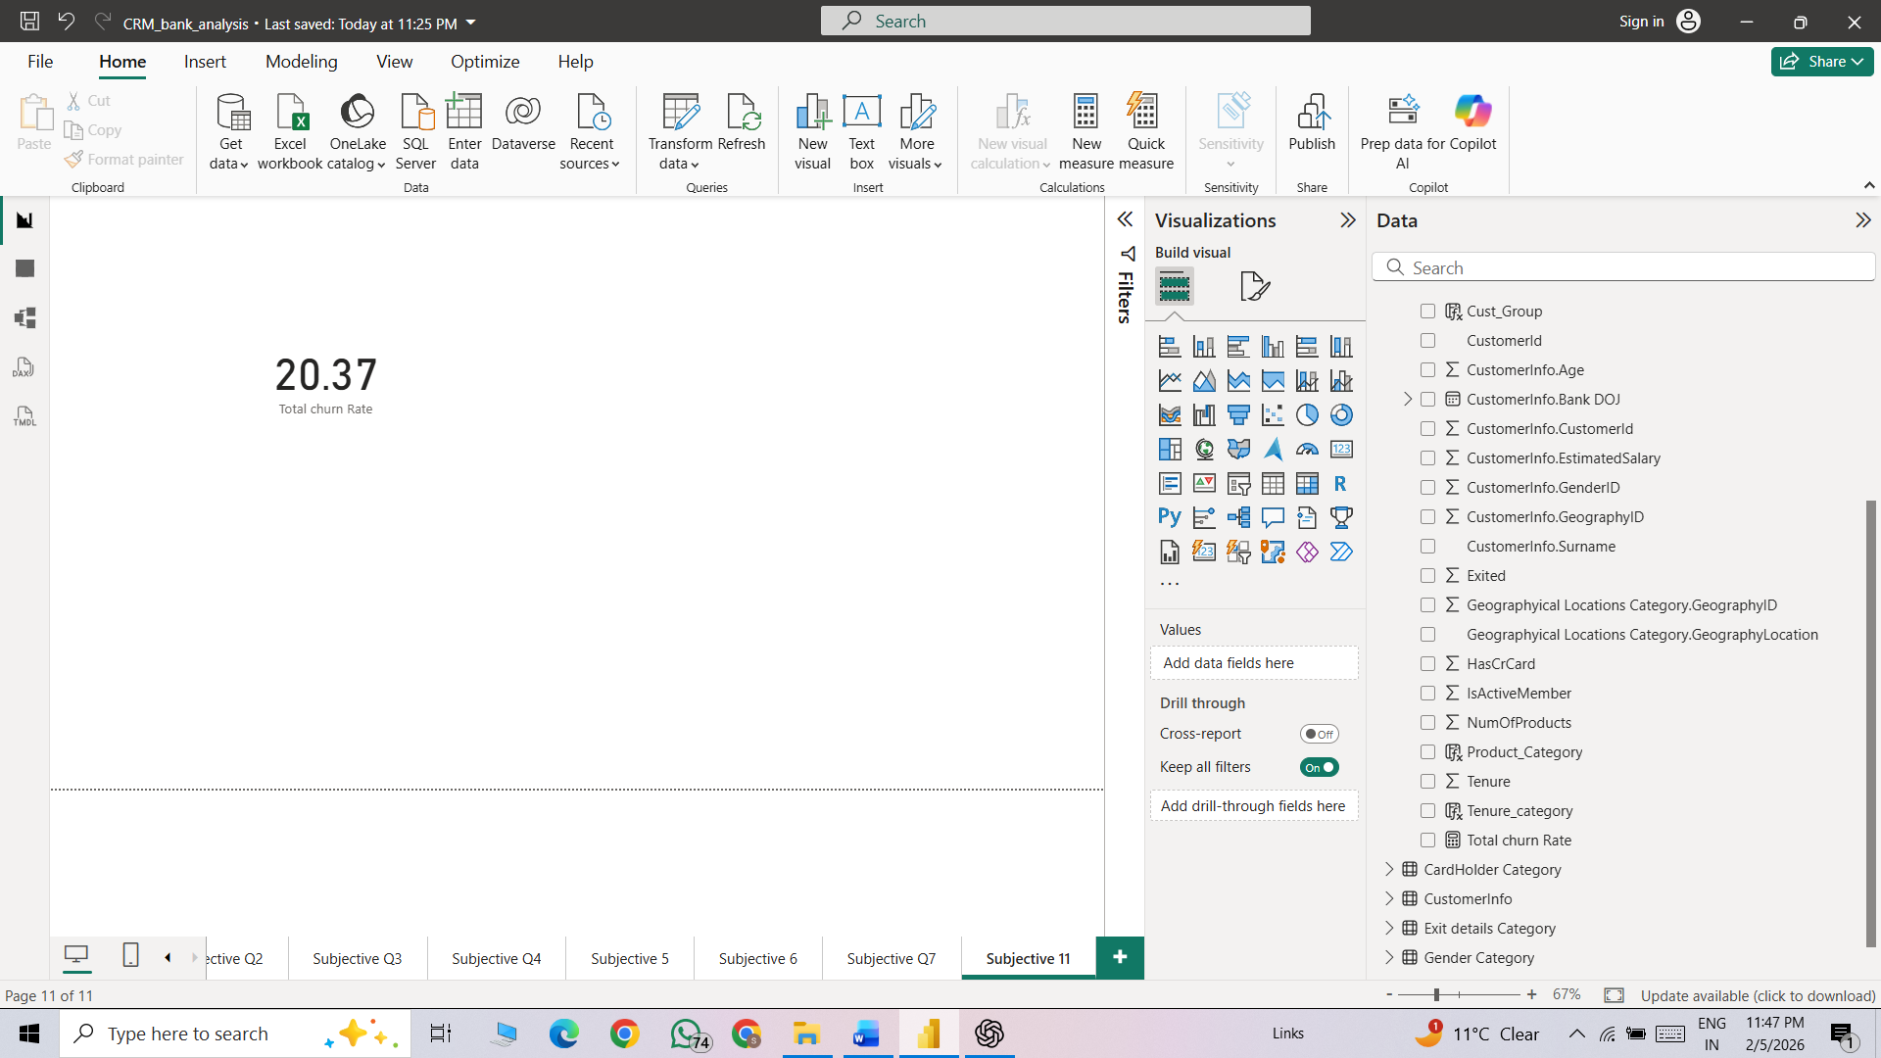
Visualization:
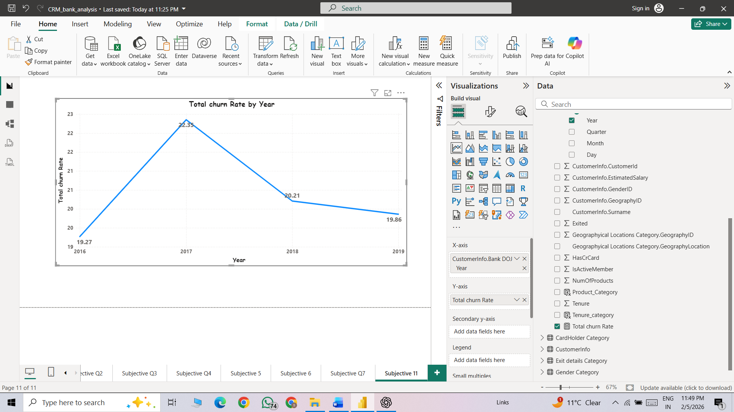
Approach:
- Objective: What is the current churn rate per year and overall, as well in the bank?
- Method: We used a DAX formula to categorize churn risk as High, Medium, or Low based on specific conditions. We then applied conditional formatting with new rules and icons to visually represent each category.
- Insights:
  - Churn increased from 19.27% (2016) to a peak of 22.35% (2017).
  - It then declined to 20.21% (2018) and 19.86% (2019).
  - Overall, churn spiked in 2017 but shows a steady improvement afterward, stabilizing around 20%.
- Recommendation:
  - Improve Customer Experience Enhance support response time, service quality, and onboarding process.
Q12. Can you suggest some insights to the bank about which kind of customers are more likely to churn and what different strategies can be used to decrease the churn rate?
Low Account Balance Customers
- Customers with low balances tend to churn more as they see less value in maintaining the account.
Customers with Short Tenure
- Newer customers (low tenure) have a higher churn risk due to weak relationship and low trust with the bank.
Inactive Customers
- Customers with low transaction frequency or no recent activity are more likely to leave.
Customers Without Credit Cards
- Customers who do not hold a credit card show higher churn, indicating lower product engagement.
Single-Product Customers
- Customers using only one banking product are more likely to churn compared to multi-product users.
Certain Demographic Segments
- Middle-aged customers with moderate income and low engagement often show higher churn rates.
- Strategies to Reduce Customer Churn
- Early Engagement for New Customers
  - Provide onboarding support, welcome offers, and personalized communication during the first 6-12 months.
- Targeted Offers for Low-Balance Customers
  - Introduce minimum-balance benefits, fee waivers, or savings-linked rewards.
- Increase Product Adoption
  - Encourage customers to use additional products (credit cards, loans, digital banking) through personalized cross-selling.
- Re-Engagement Campaigns for Inactive Users
  - Send reminders, cashback offers, or exclusive deals to customers with low transaction activity.
5. Loyalty & Retention Programs
  - Offer loyalty points, milestone rewards, and tenure-based benefits to long-term customers.
- Personalized Communication
  - Use customer behavior data to send relevant, timely messages instead of generic campaigns.
Q13. Create a dashboard incorporating all the KPIs and visualization-related metrics. Use a slicer in order to assist in selection in the dashboard.

Q14. How would you approach this problem, if the objective and subjective questions weren't given?
Step 1: Understand the Business and the Data
- Clarify the business goal: reduce customer churn and improve retention.
- Define what churn means (e.g., customer closed account, inactive for a defined period).
- Understand the banking context: customer lifecycle, products offered (savings, credit card, loans).
- Review available data tables and fields such as:
  - Customer demographics (age, gender, geography)
  - Account information (balance, tenure)
  - Product usage (credit card, number of products)
  - Activity indicators (transactions, active/inactive)
- Identify stakeholders and how insights will support business decisions.

Step 2: Explore and Clean the Data
- Check data structure, data types, and relationships between tables.
- Handle missing values, duplicates, and inconsistent records.
- Standardize categorical values (e.g., Yes/No, Active/Inactive).
- Identify outliers in numerical fields like balance, salary, or tenure.
- Validate data quality to ensure reliability for analysis.

Step 3: Identify Key Metrics
- Churn Rate (overall and segmented)
- Active vs Inactive Customer Percentage
- Average Balance by Churn Status
- Product Holding Metrics (credit card usage, number of products)
- Customer Tenure Distribution
- Customer Lifetime Indicators (engagement, transactions)
- Segment-wise churn (by age group, geography, balance category)

Step 4: Analyze the Data
- Compare churned vs retained customers across key dimensions.
- Perform segmentation analysis:
  - By tenure (new vs long-term customers)
  - By balance (low, medium, high)
  - By product usage (single vs multi-product)
- Identify patterns and correlations related to churn.
- Highlight high-risk customer segments contributing most to churn.
- Translate insights into actionable business recommendations.

Step 5: Generate Insights and Recommendations
- Summarize key findings by identifying the main factors contributing to customer churn.
- Prioritize high-impact churn drivers based on business value and customer volume.
- Convert analytical findings into actionable strategies for retention (offers, engagement, support improvements).
Q15. In the “Bank_Churn” table how can you modify the name of the “HasCrCard” column to “Has_creditcard”?
In Power BI, column names are modified in Power Query by renaming the column using the Transform Data option.
Method 1: Using Power Query UI (most common)
- Open Power BI Desktop
- Go to Home → Transform data
- Select the Bank_Churn table
- Right-click on the column HasCrCard
- Click Rename
- Type Has_creditcard
- Click Close & Apply

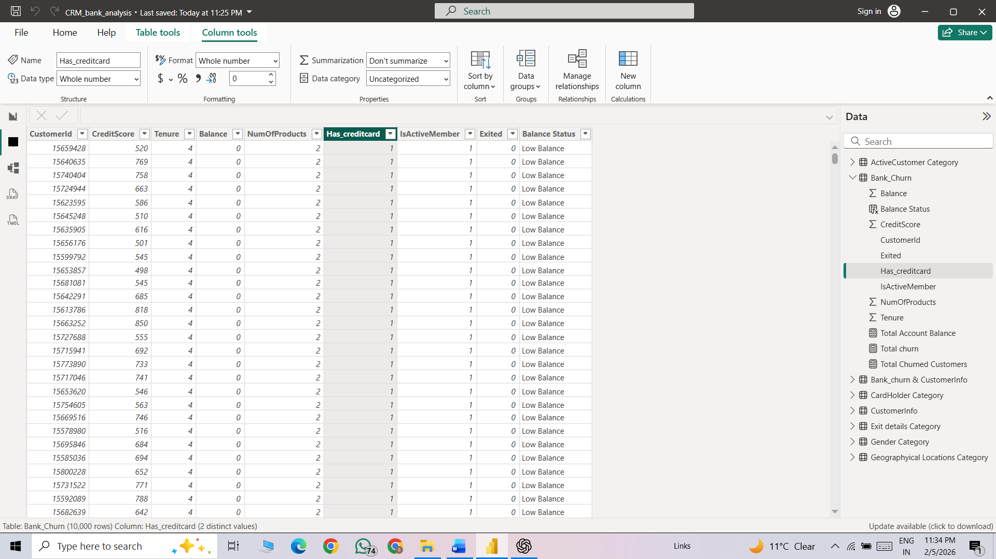

Approach:
- Objective: In the “Bank_Churn” table how can you modify the name of the HasCrCard column to Has_creditcard?
- Method: To solve these questions, we done this task using in table view then double click on headers and re-edit headers.

